AE



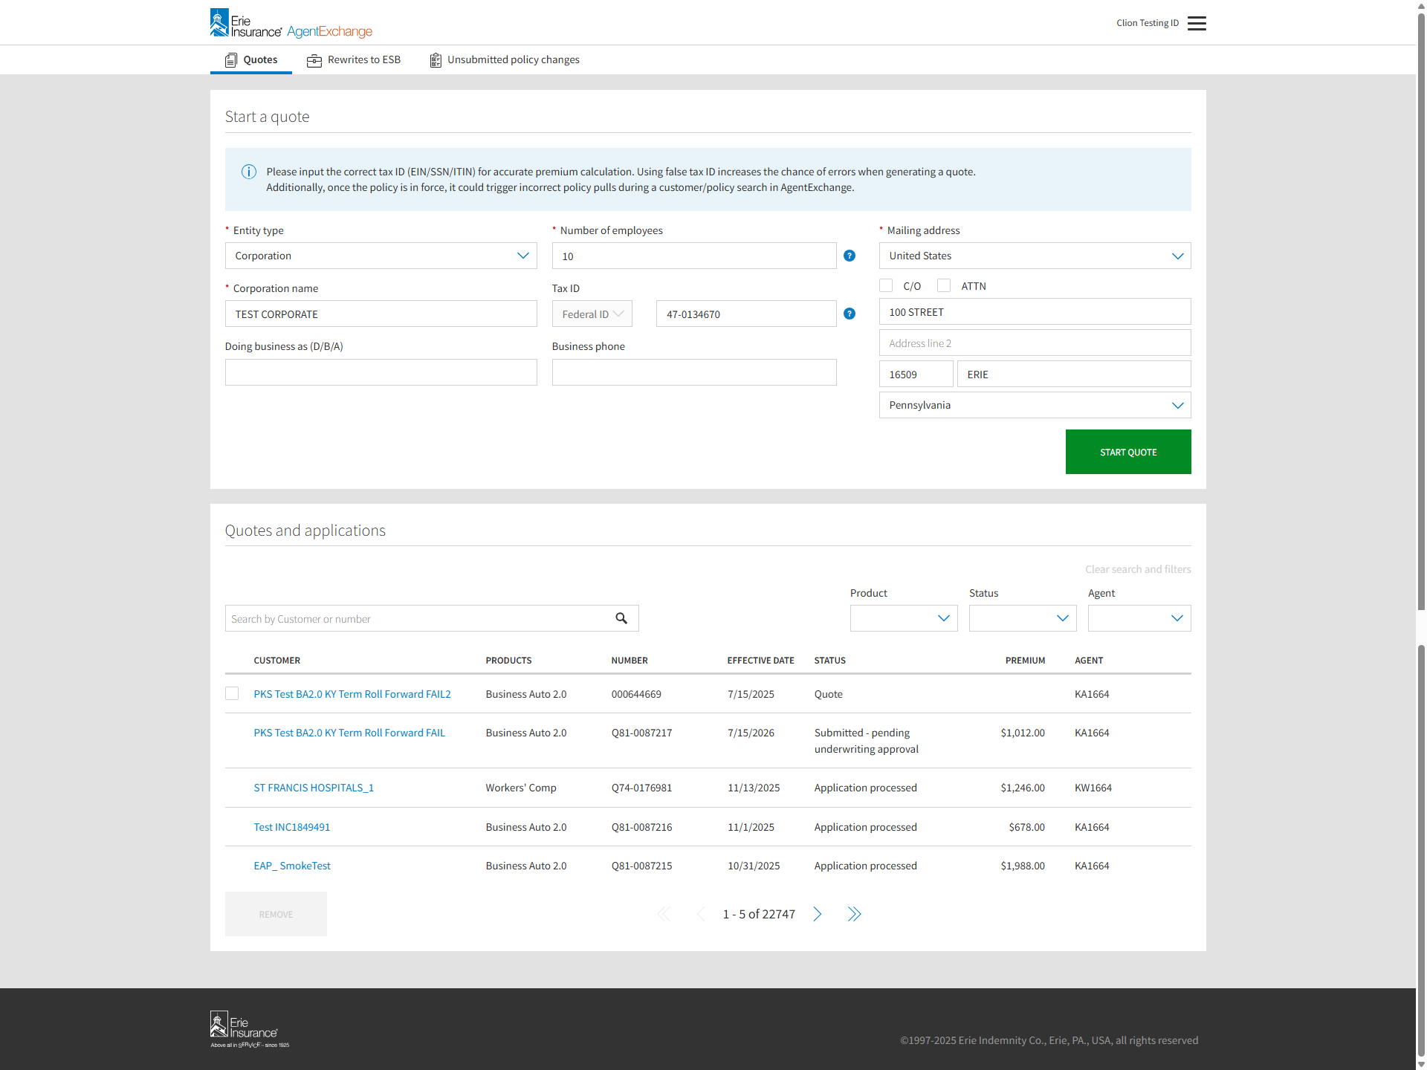

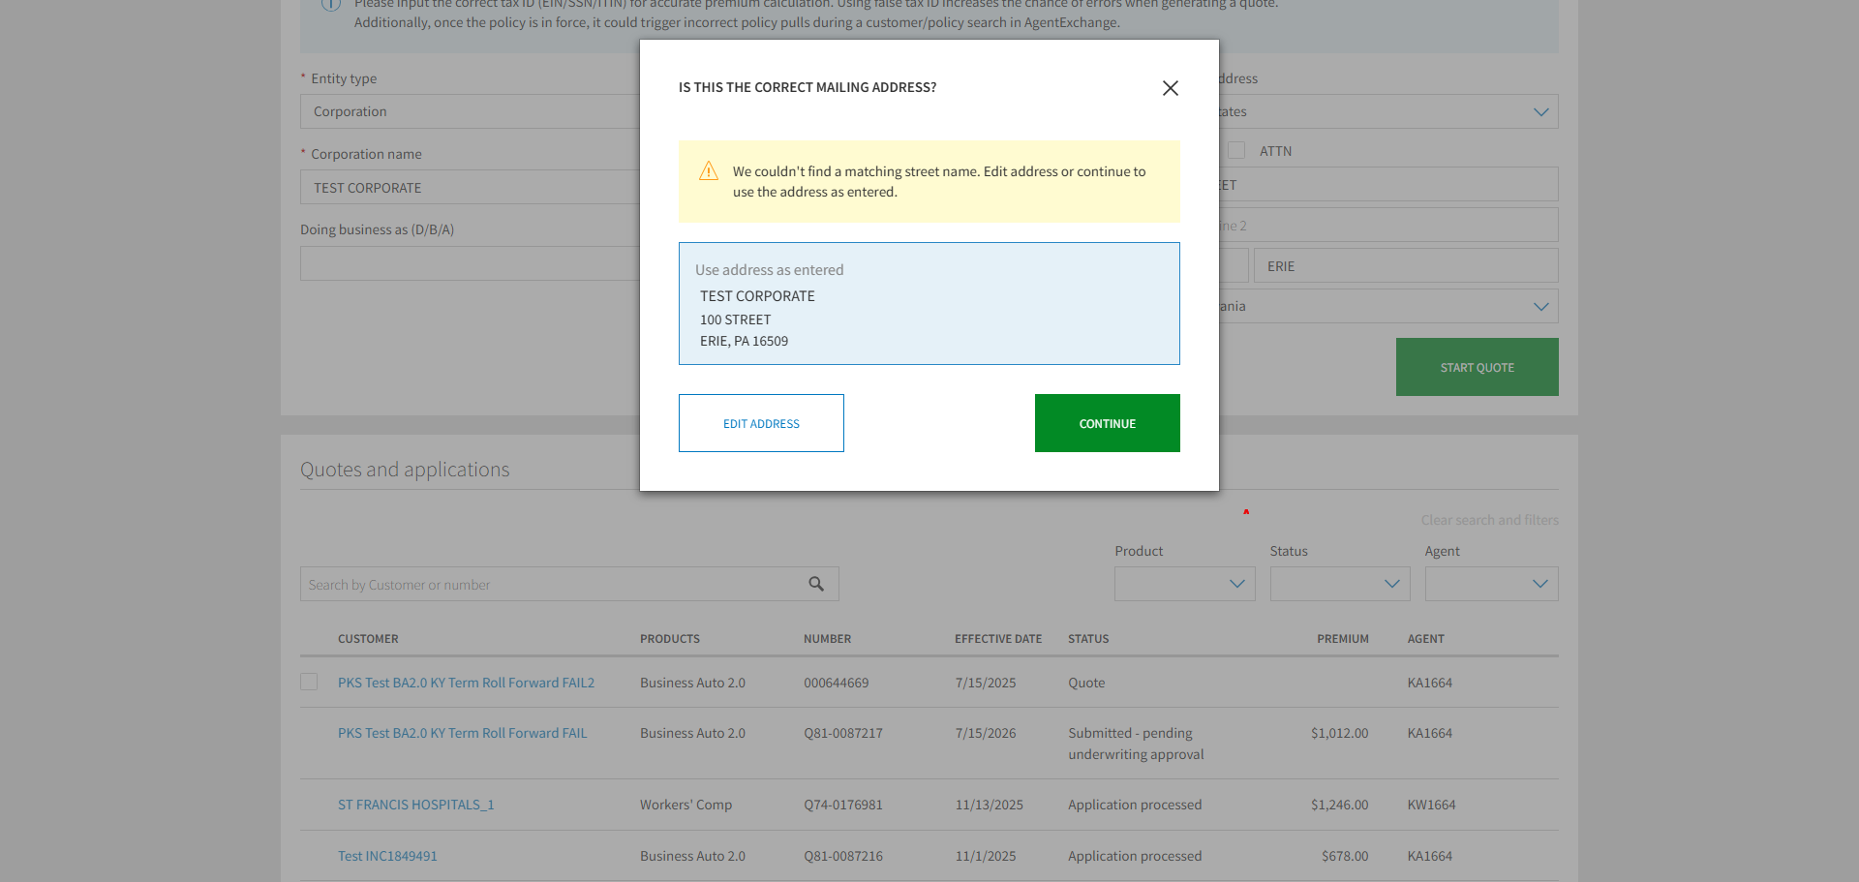

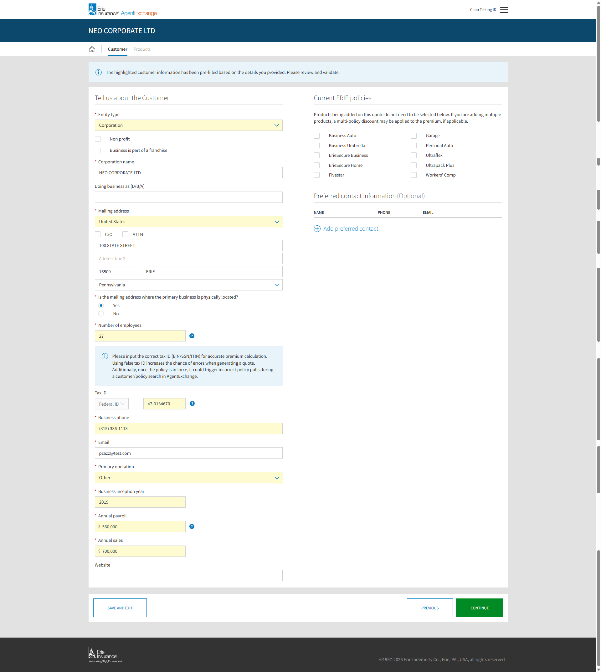

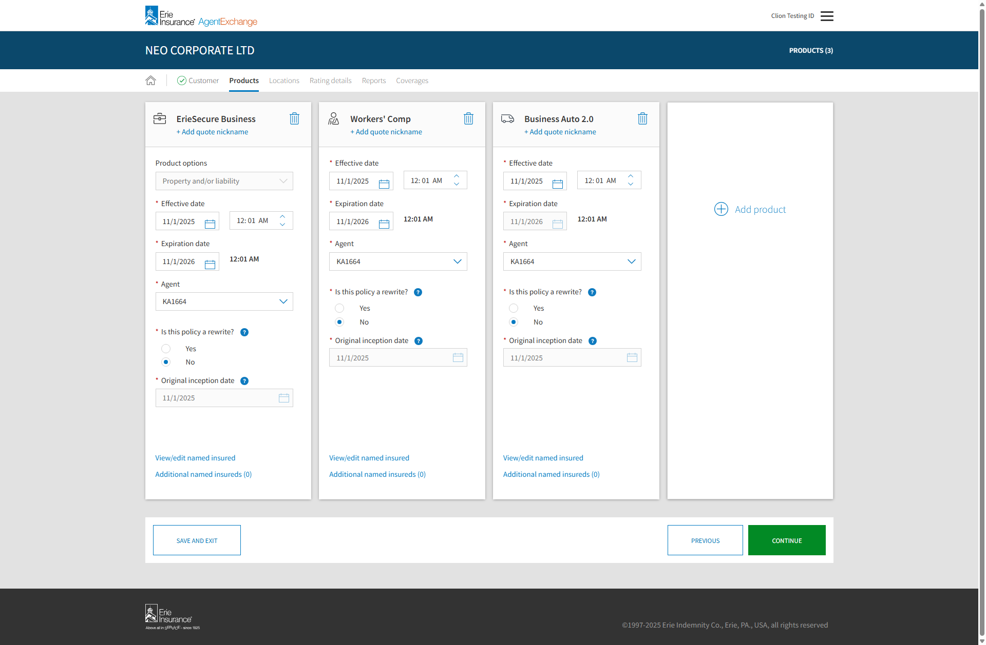

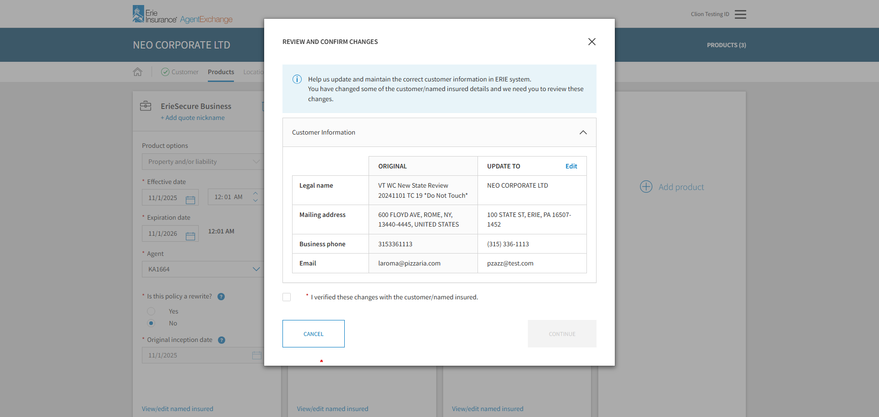

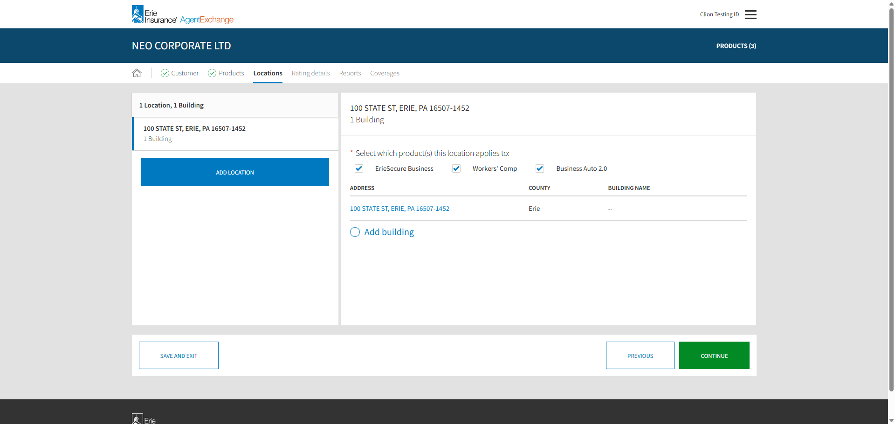

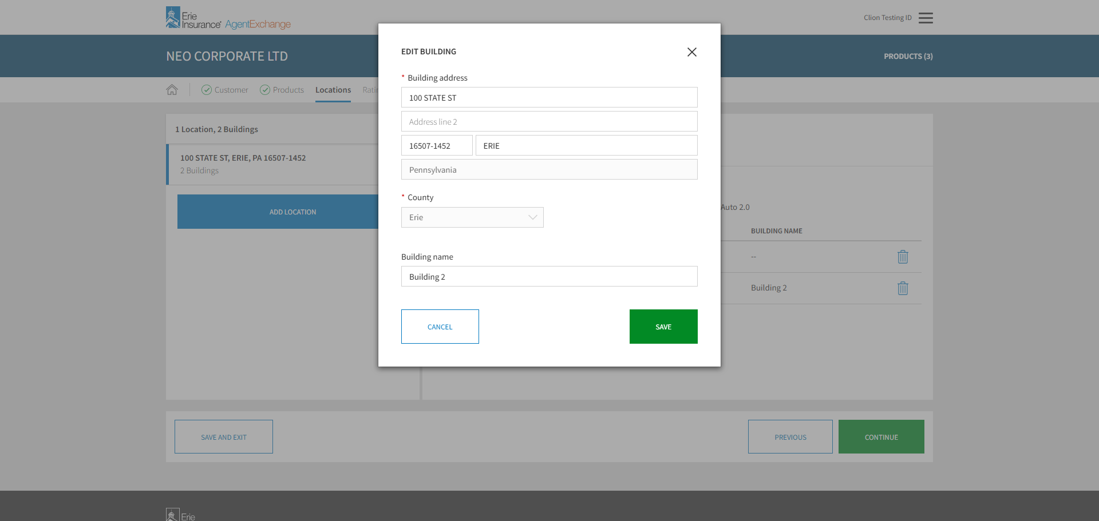

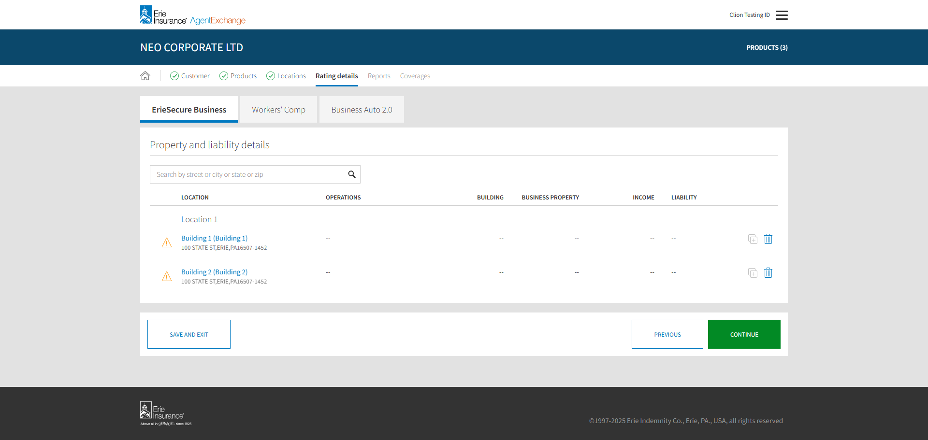

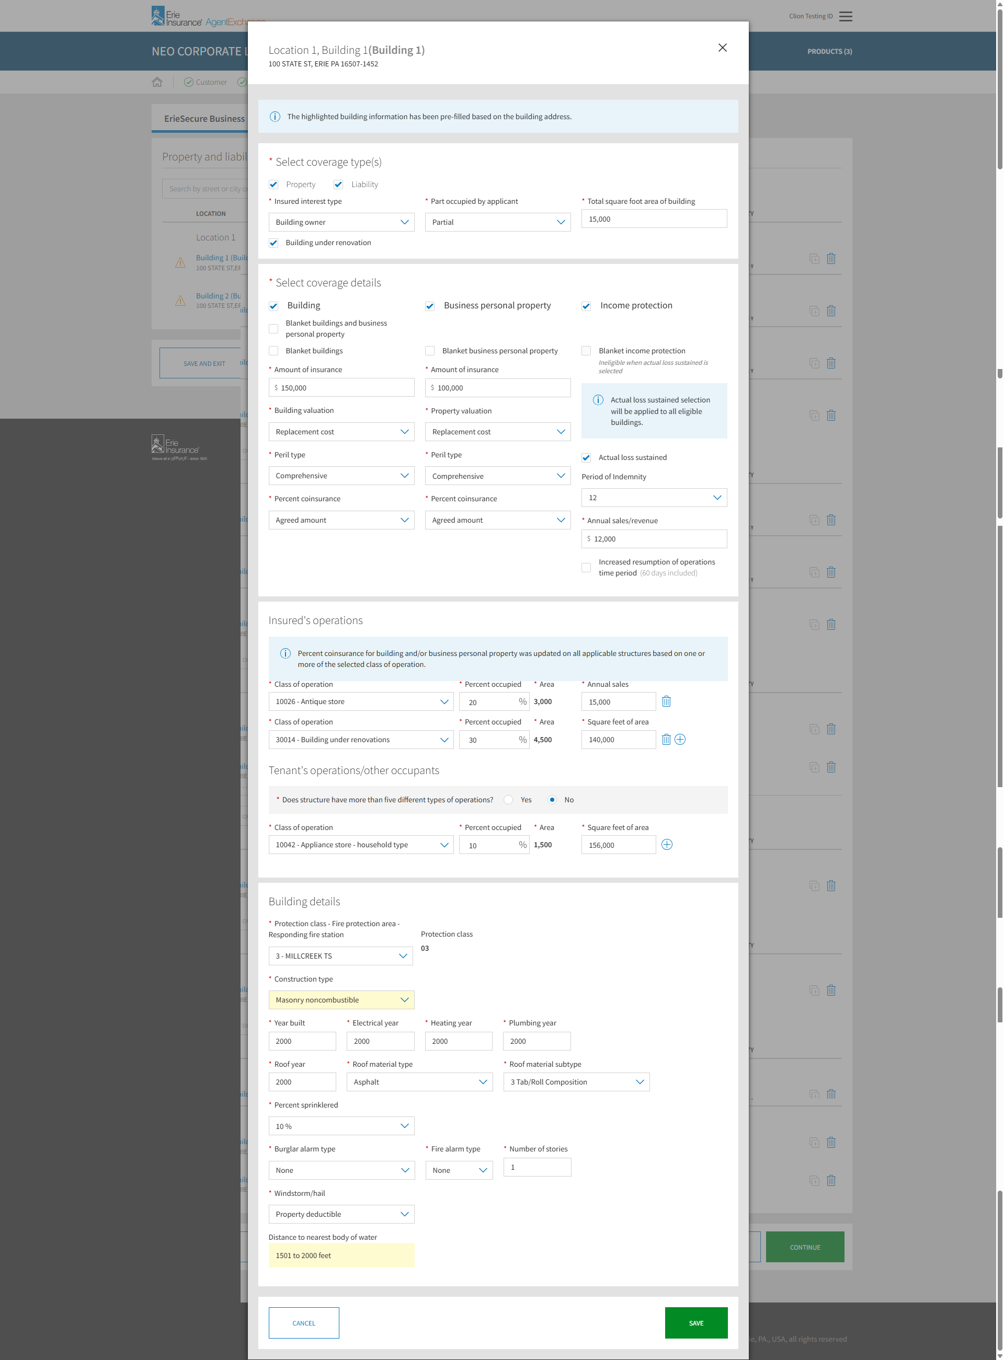

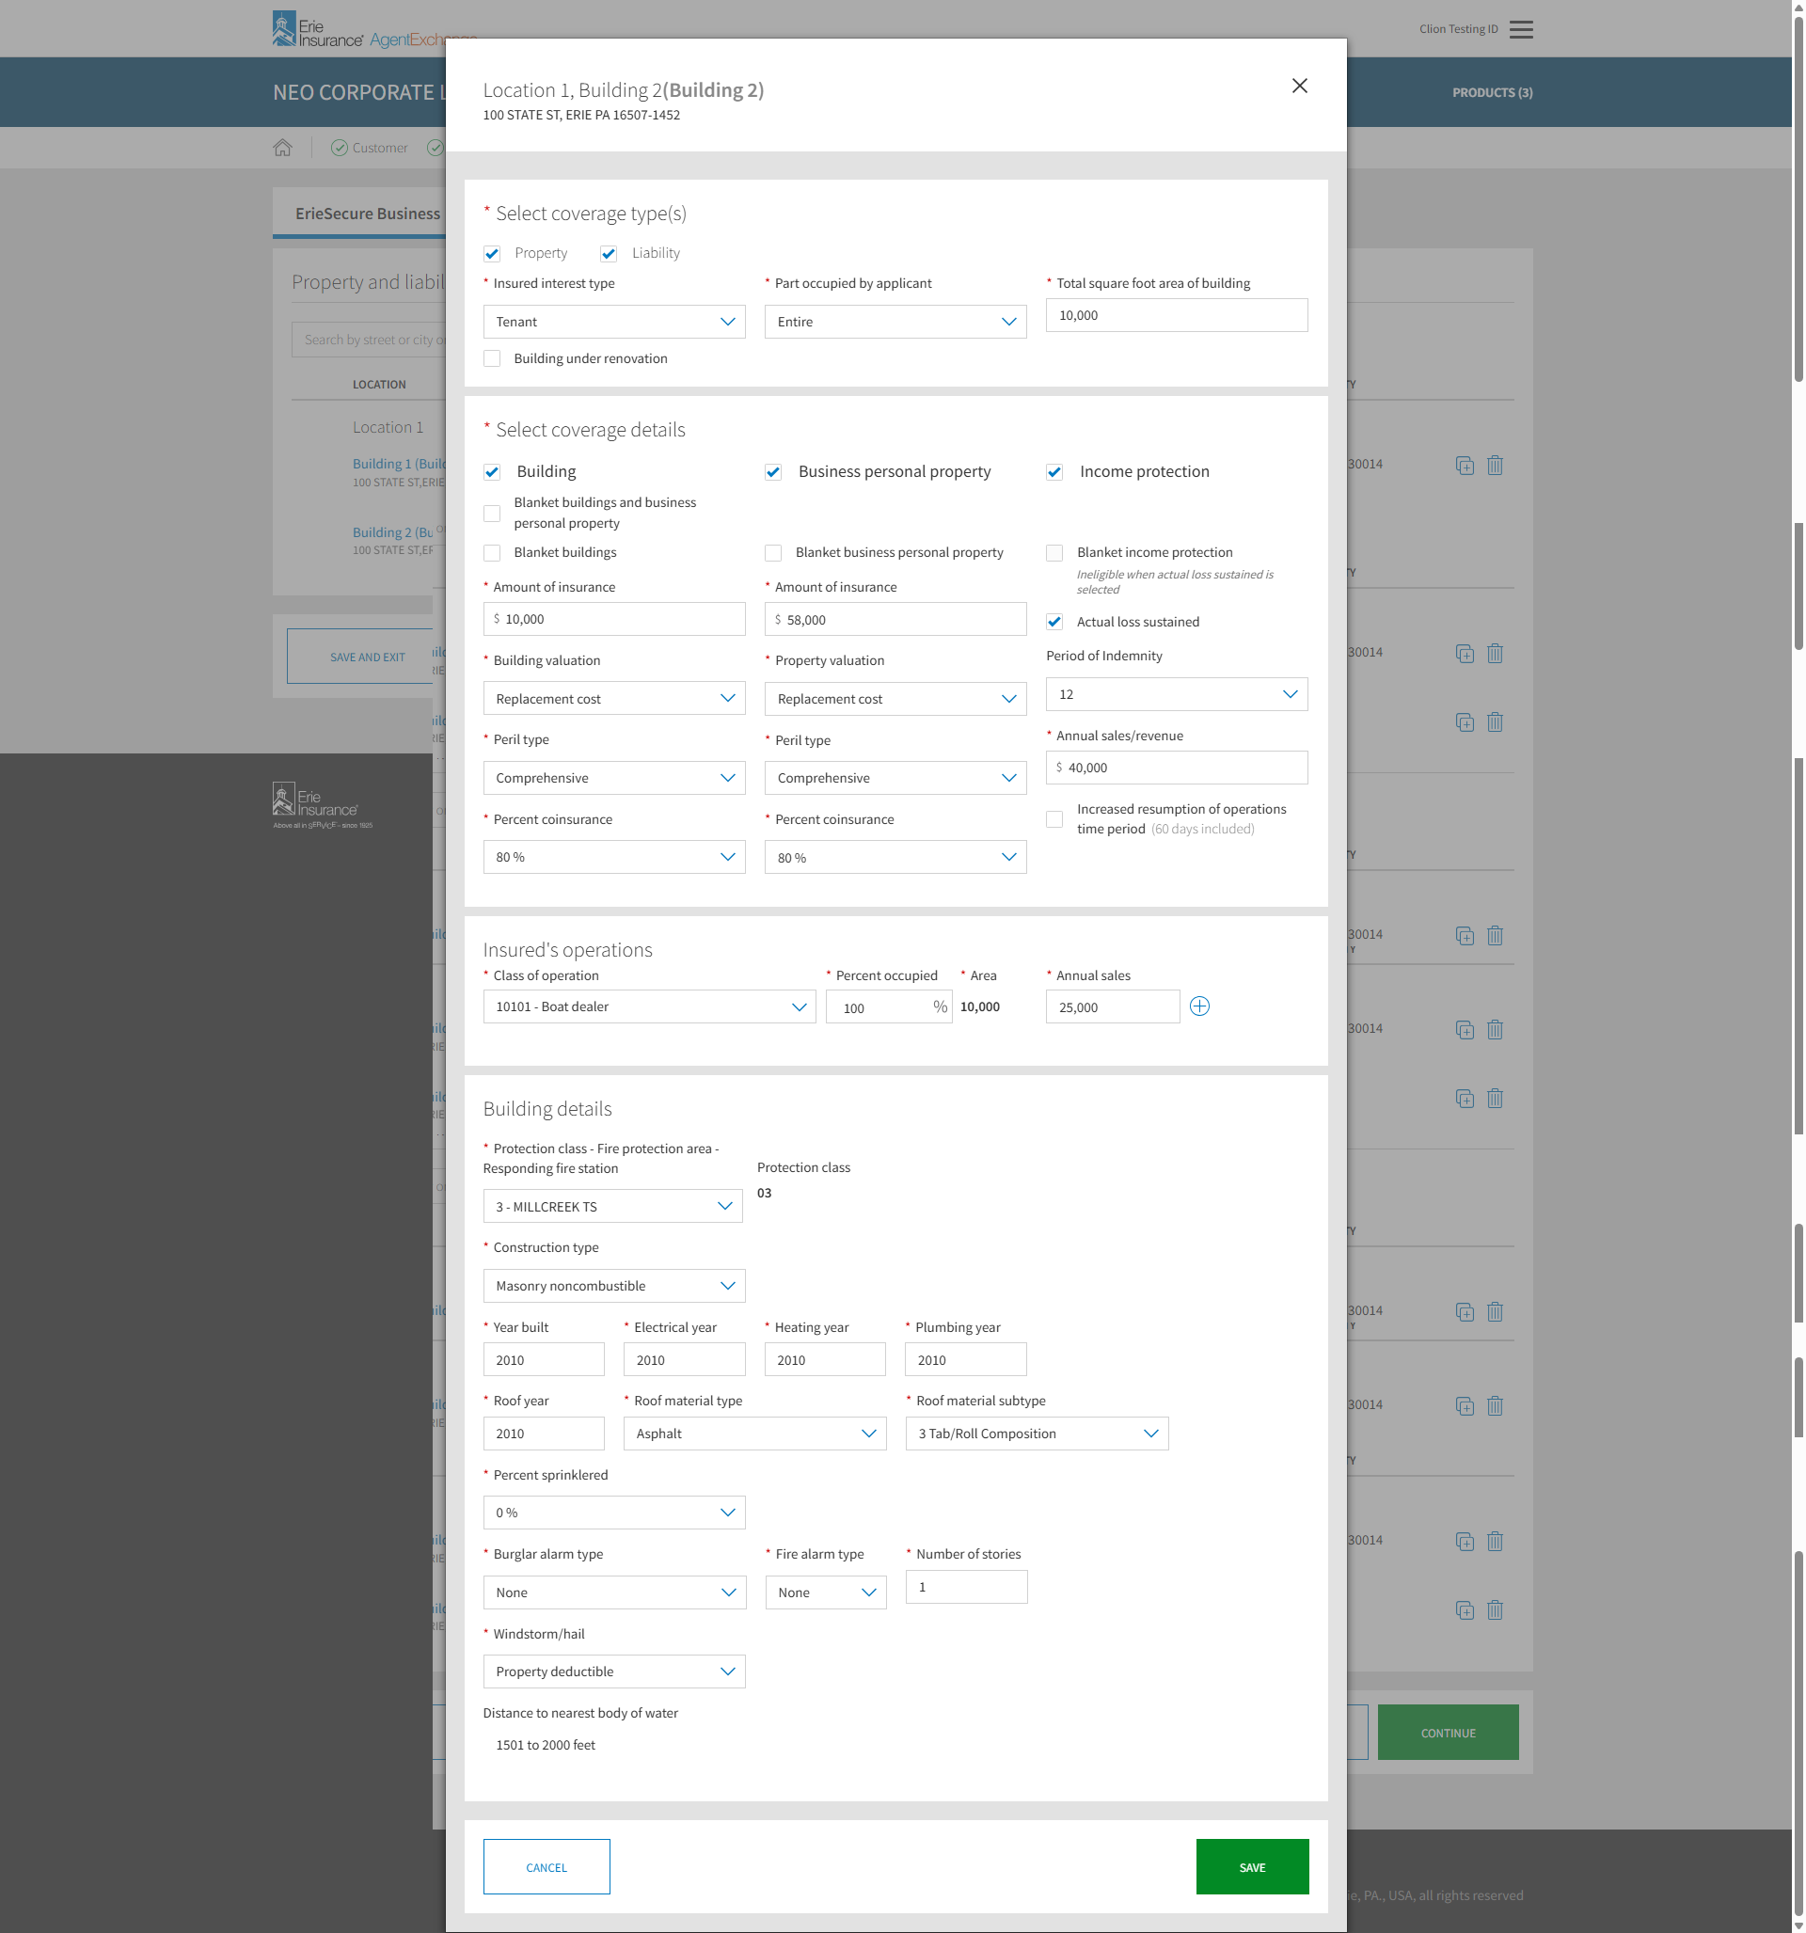

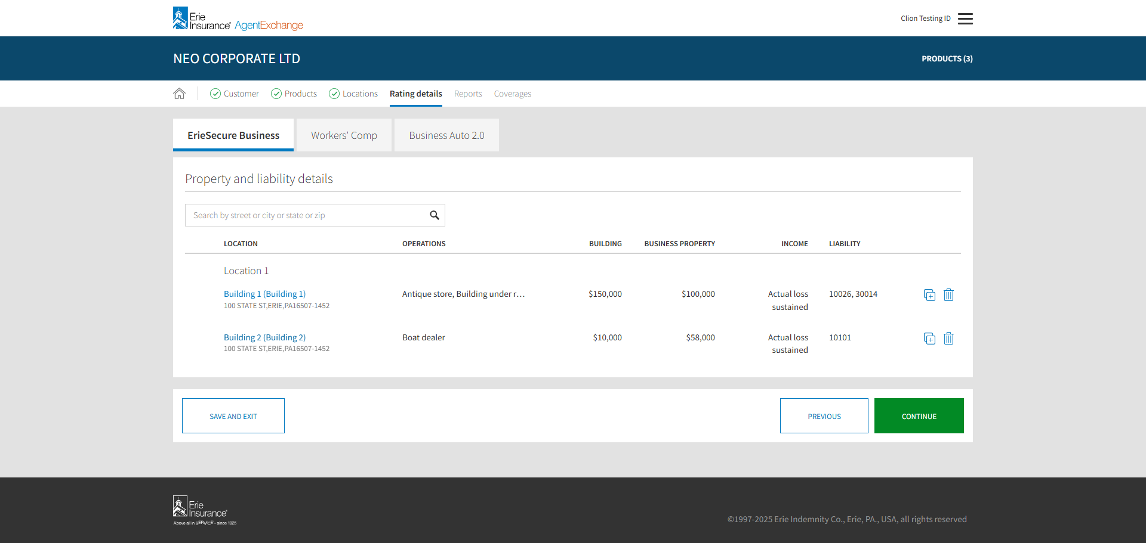

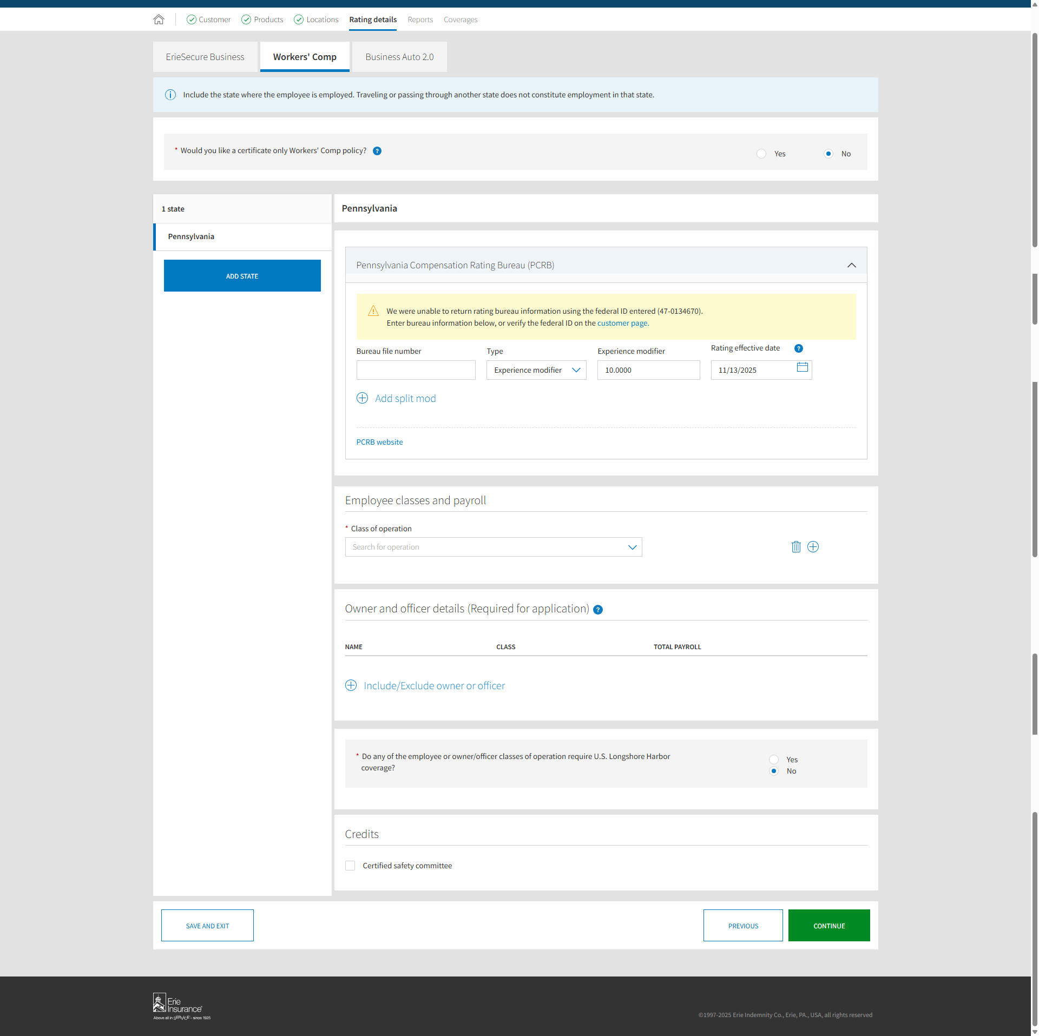

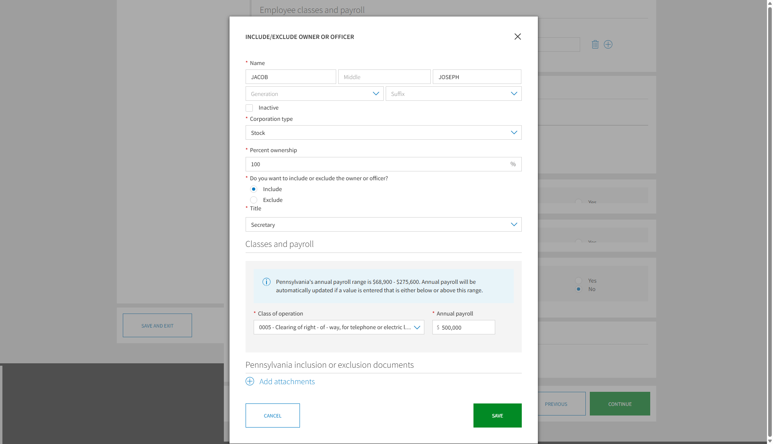

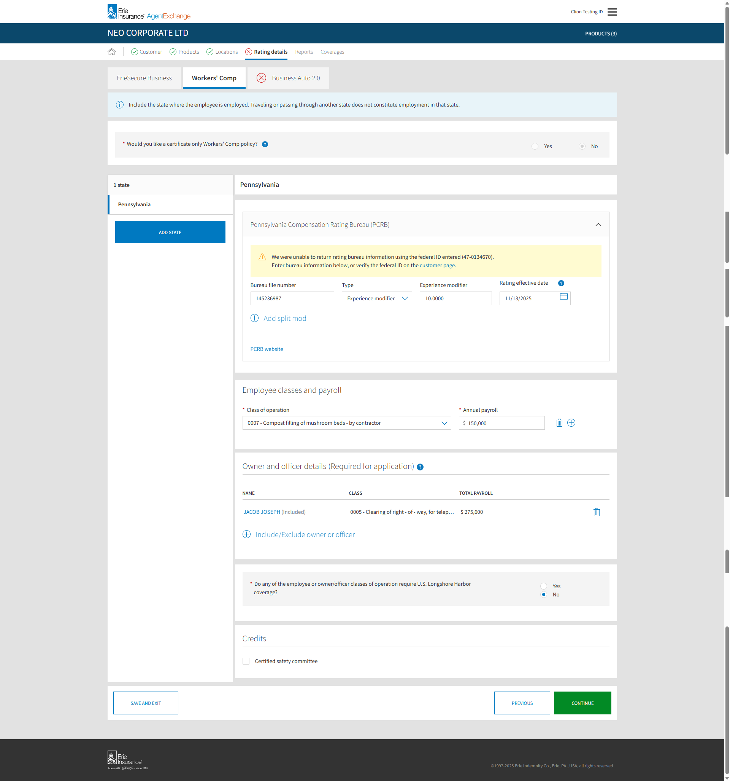

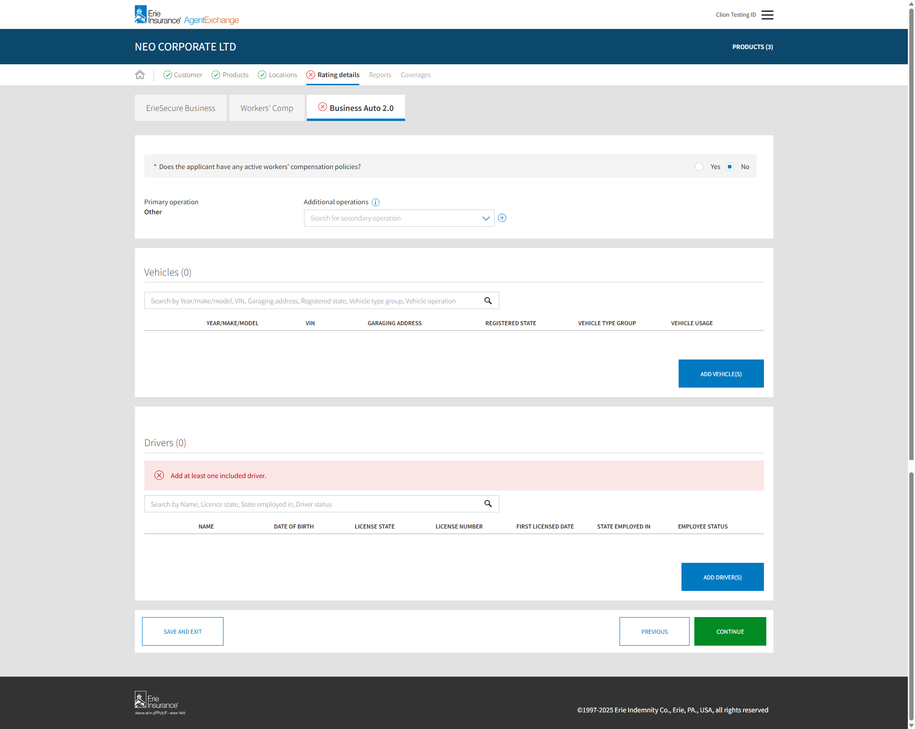

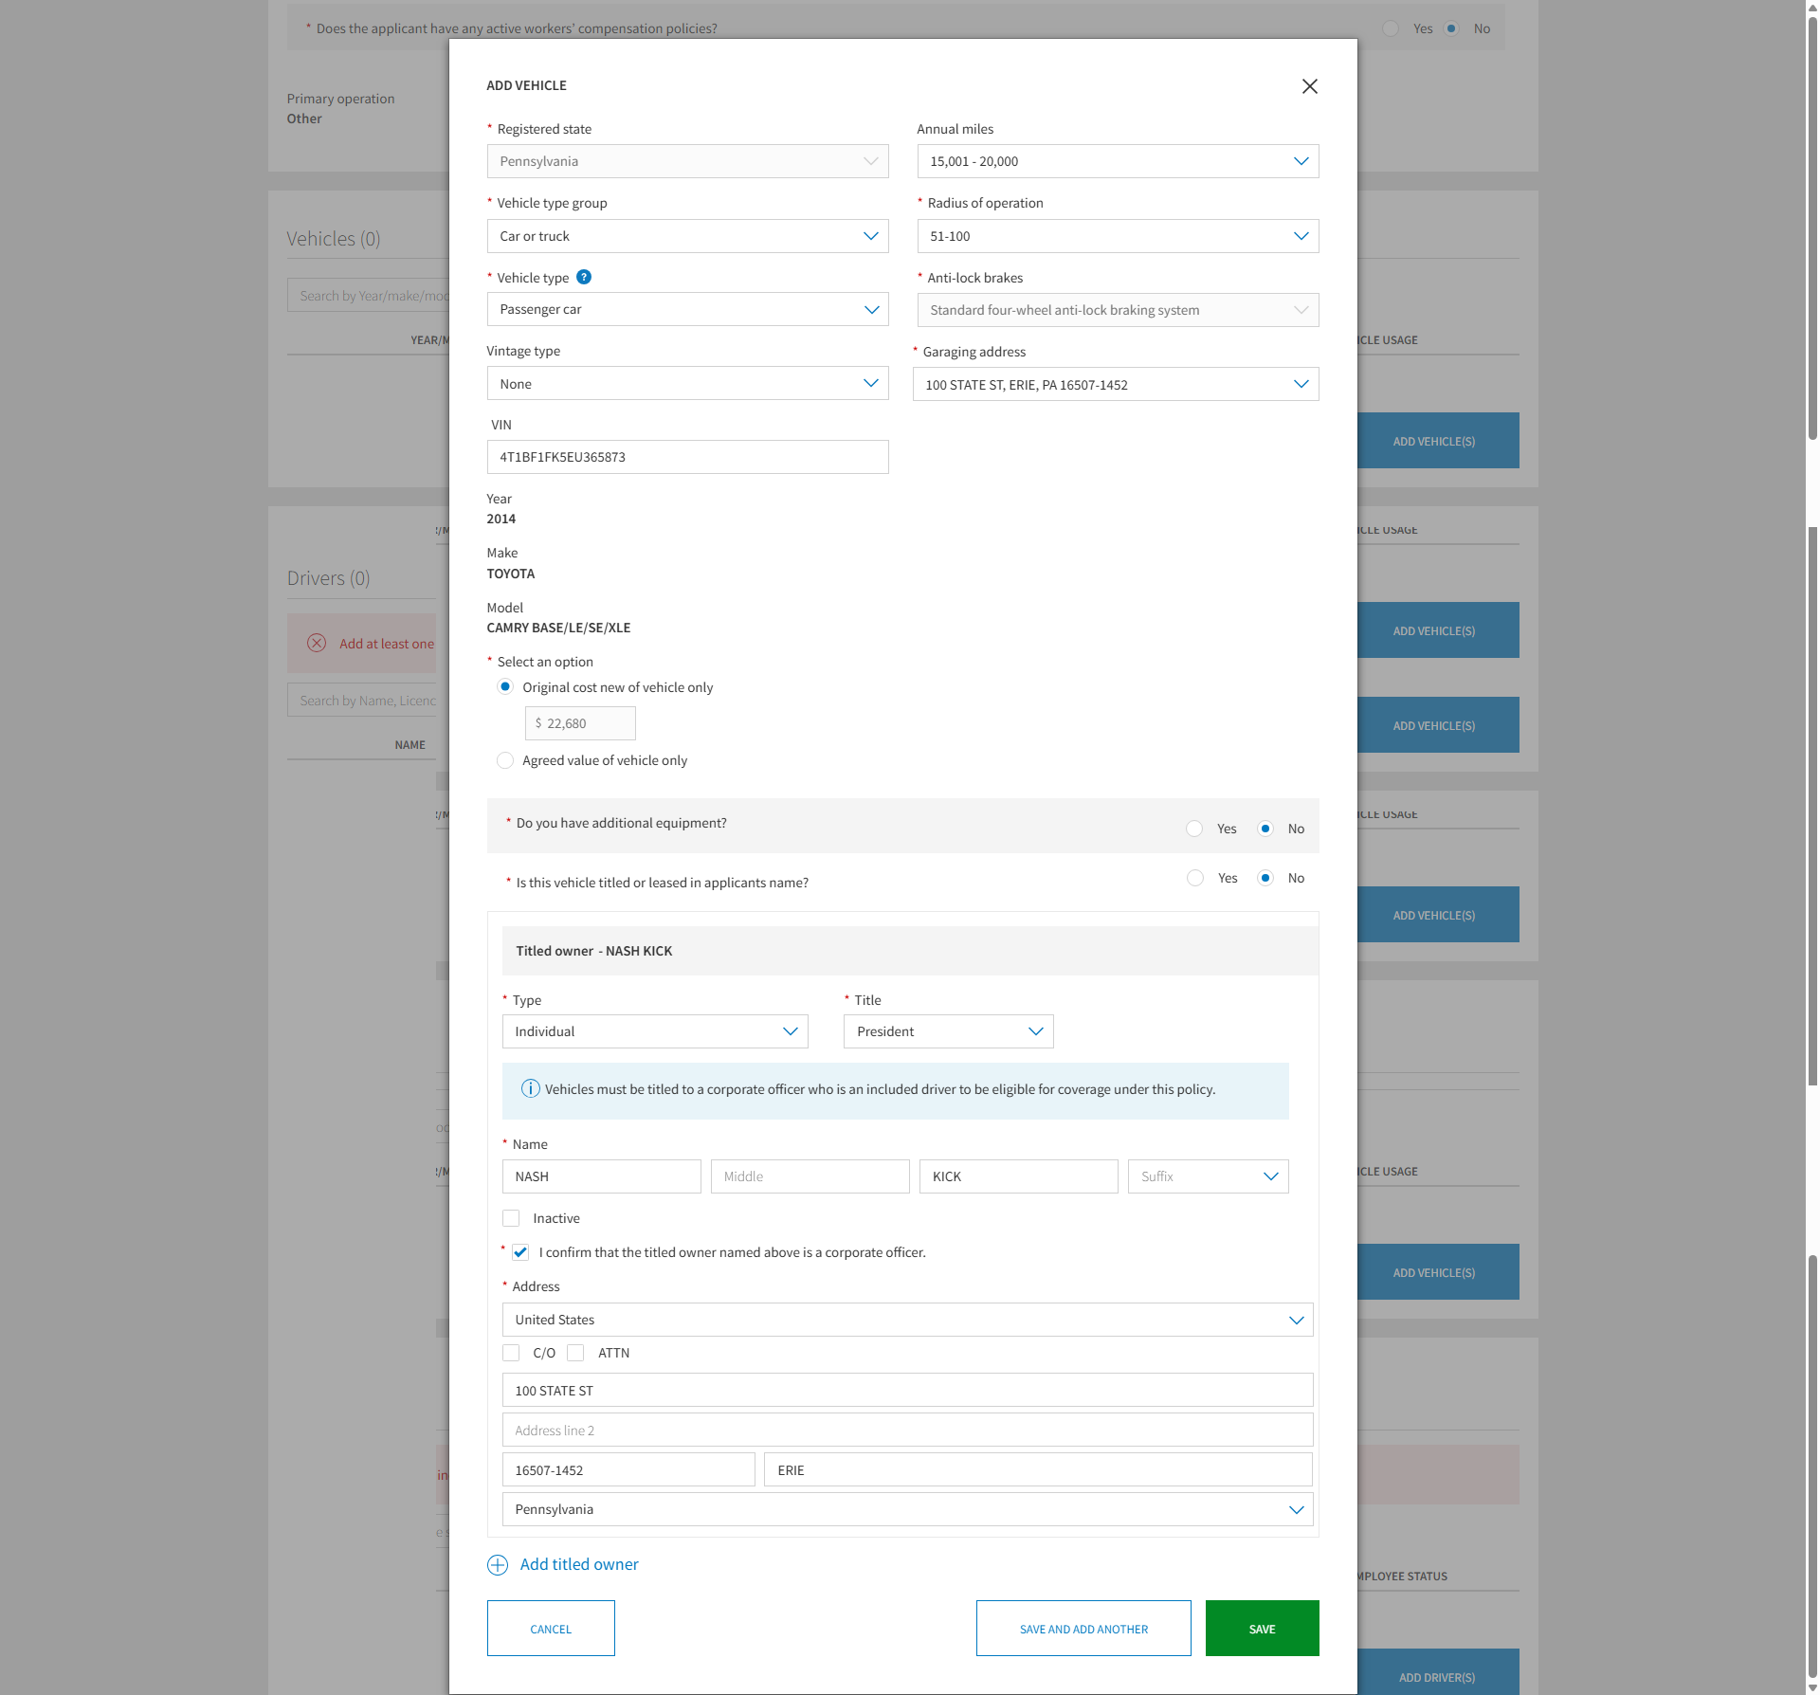

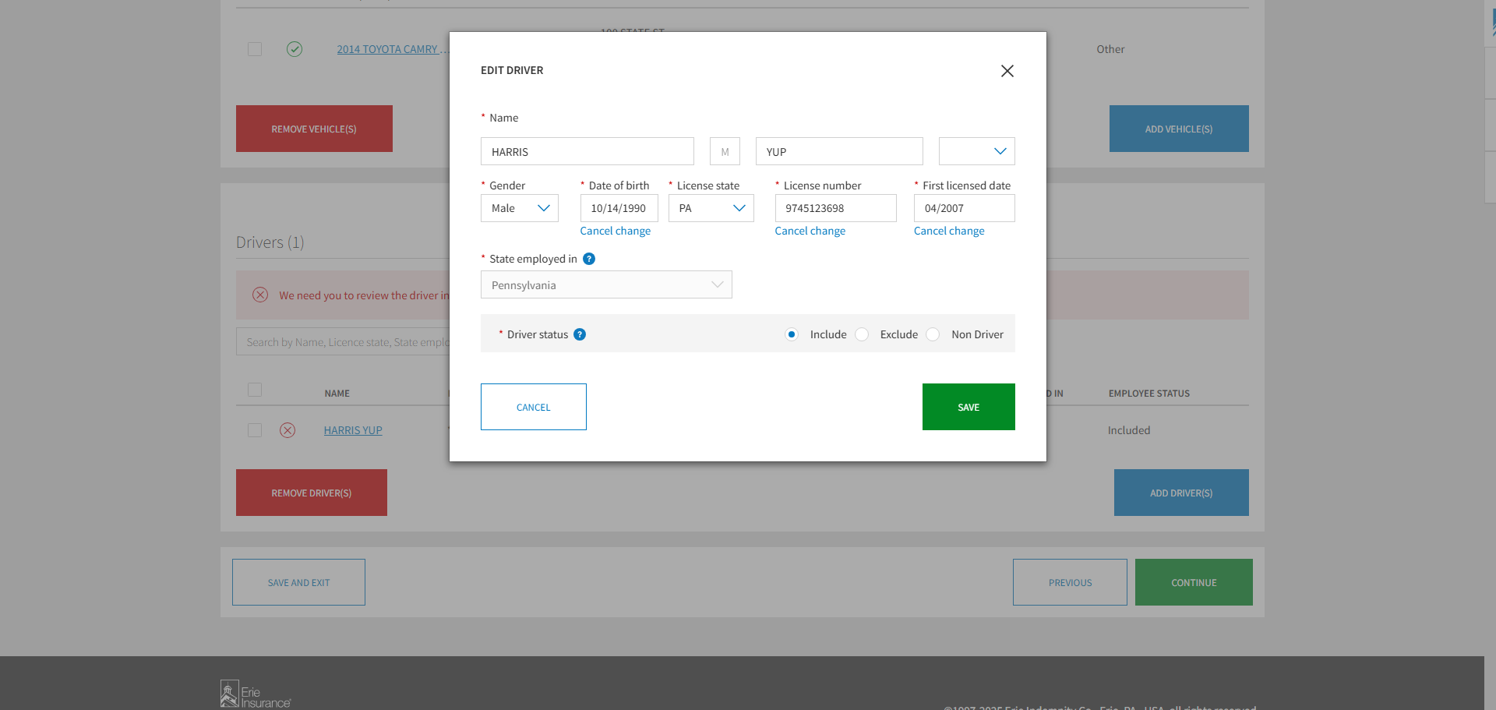

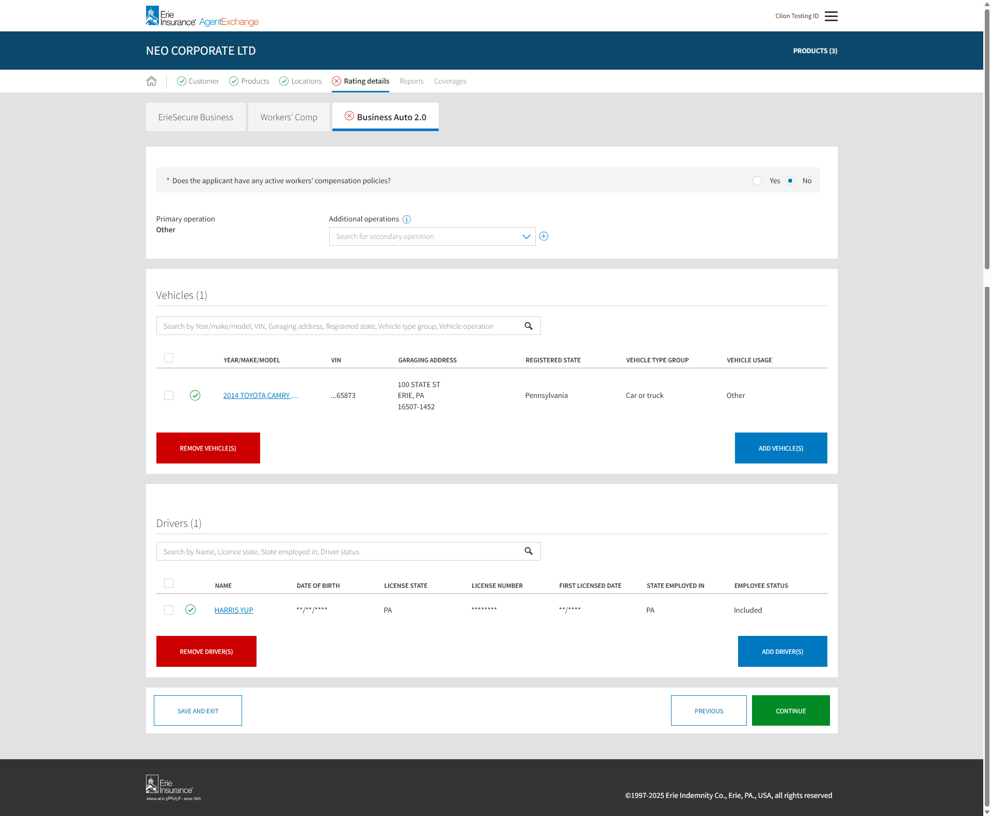

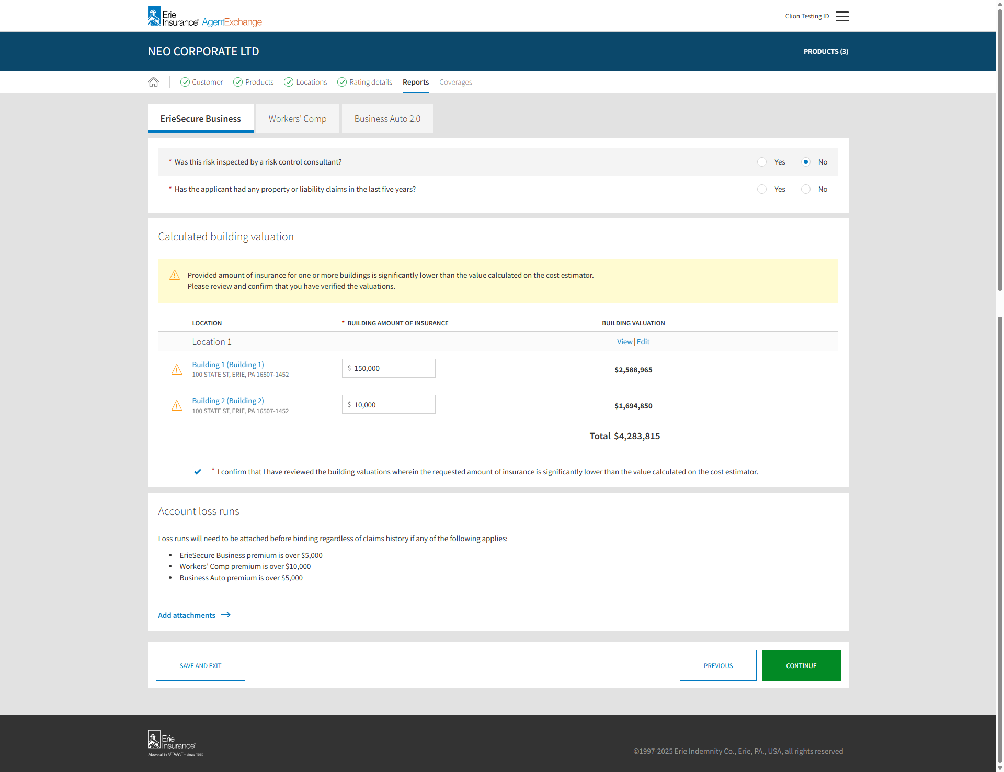

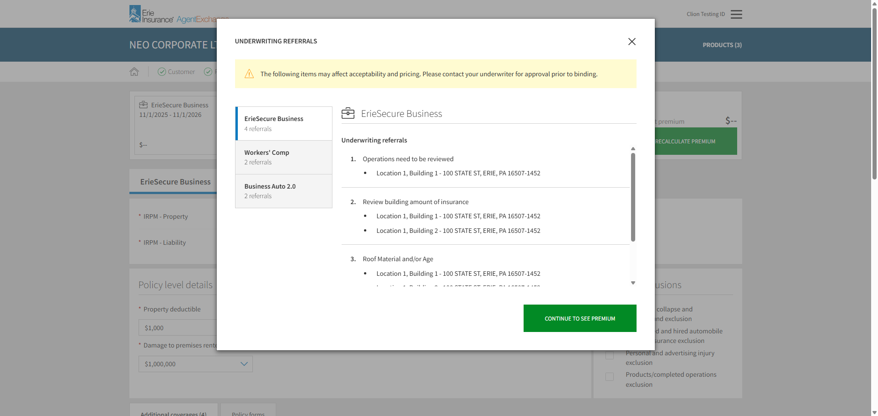

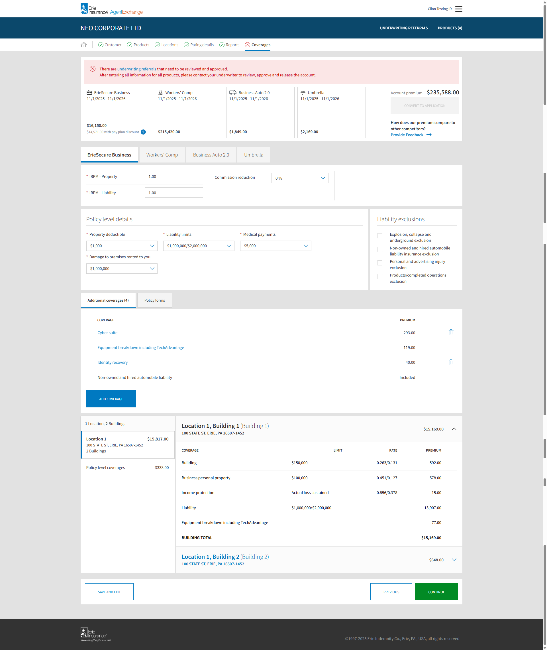

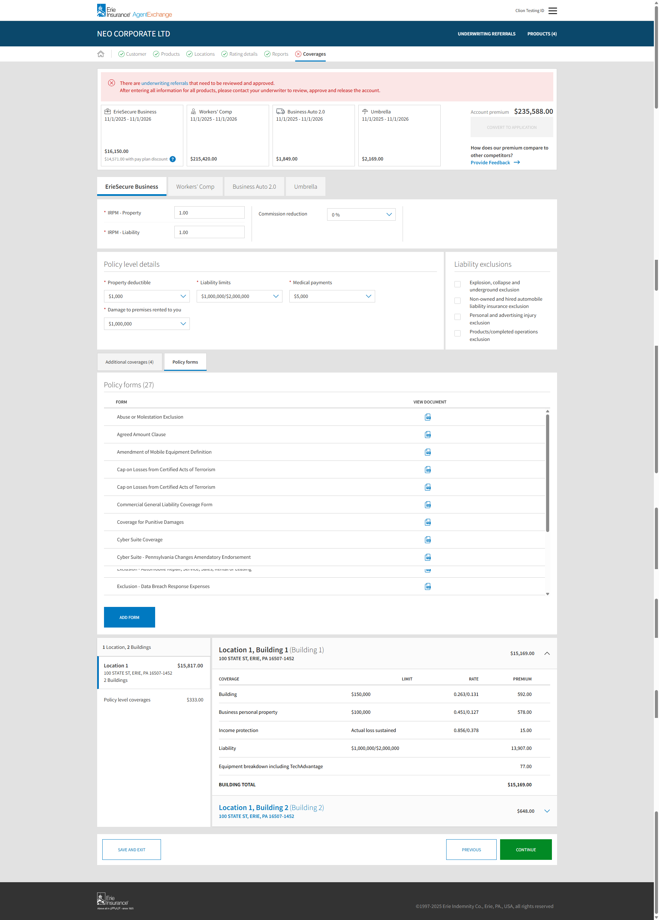

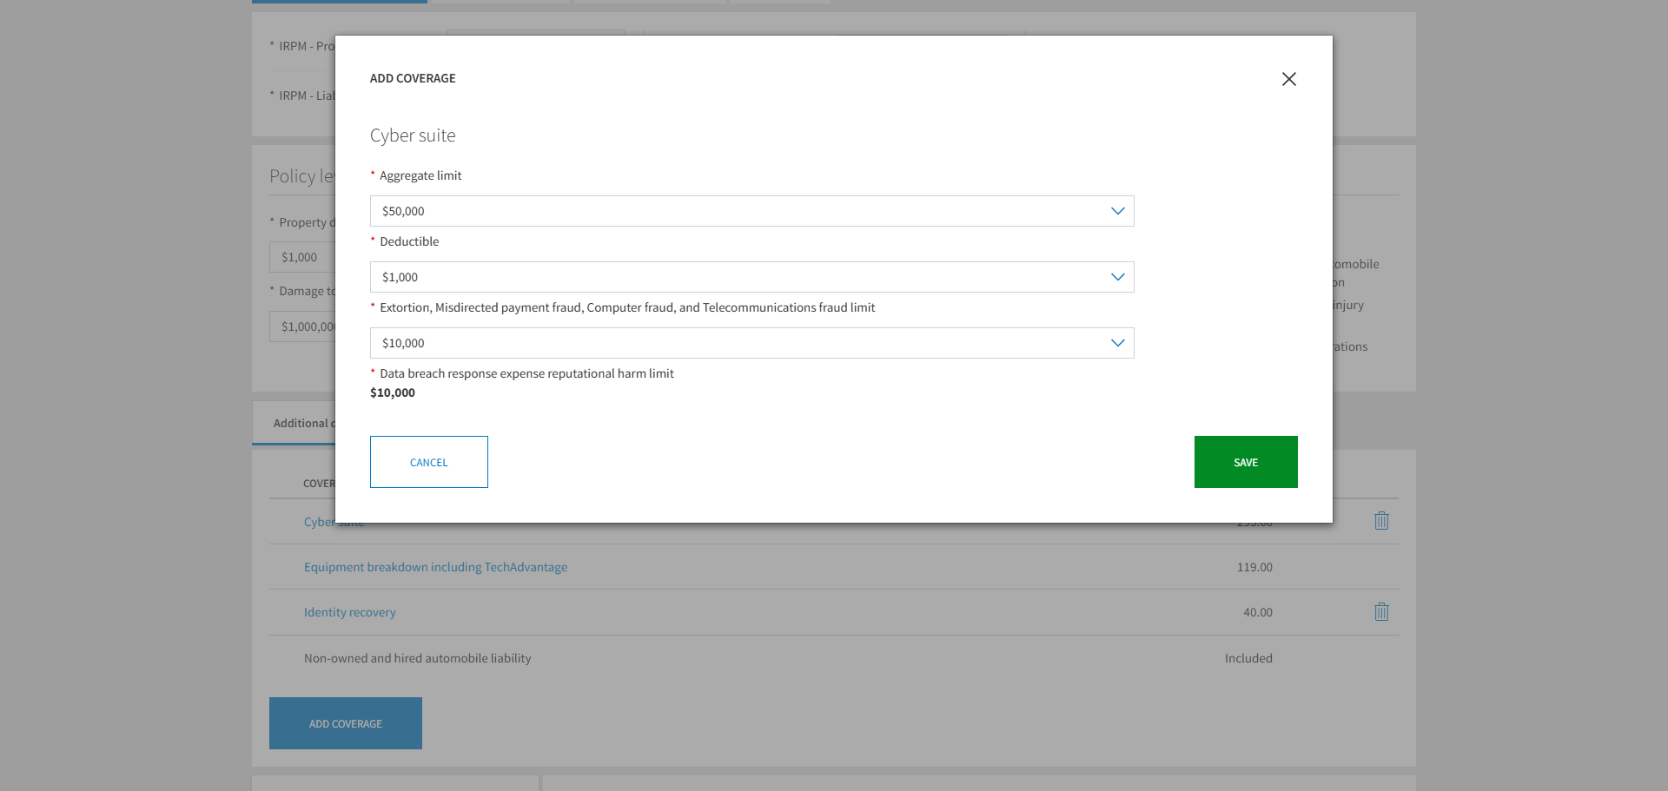

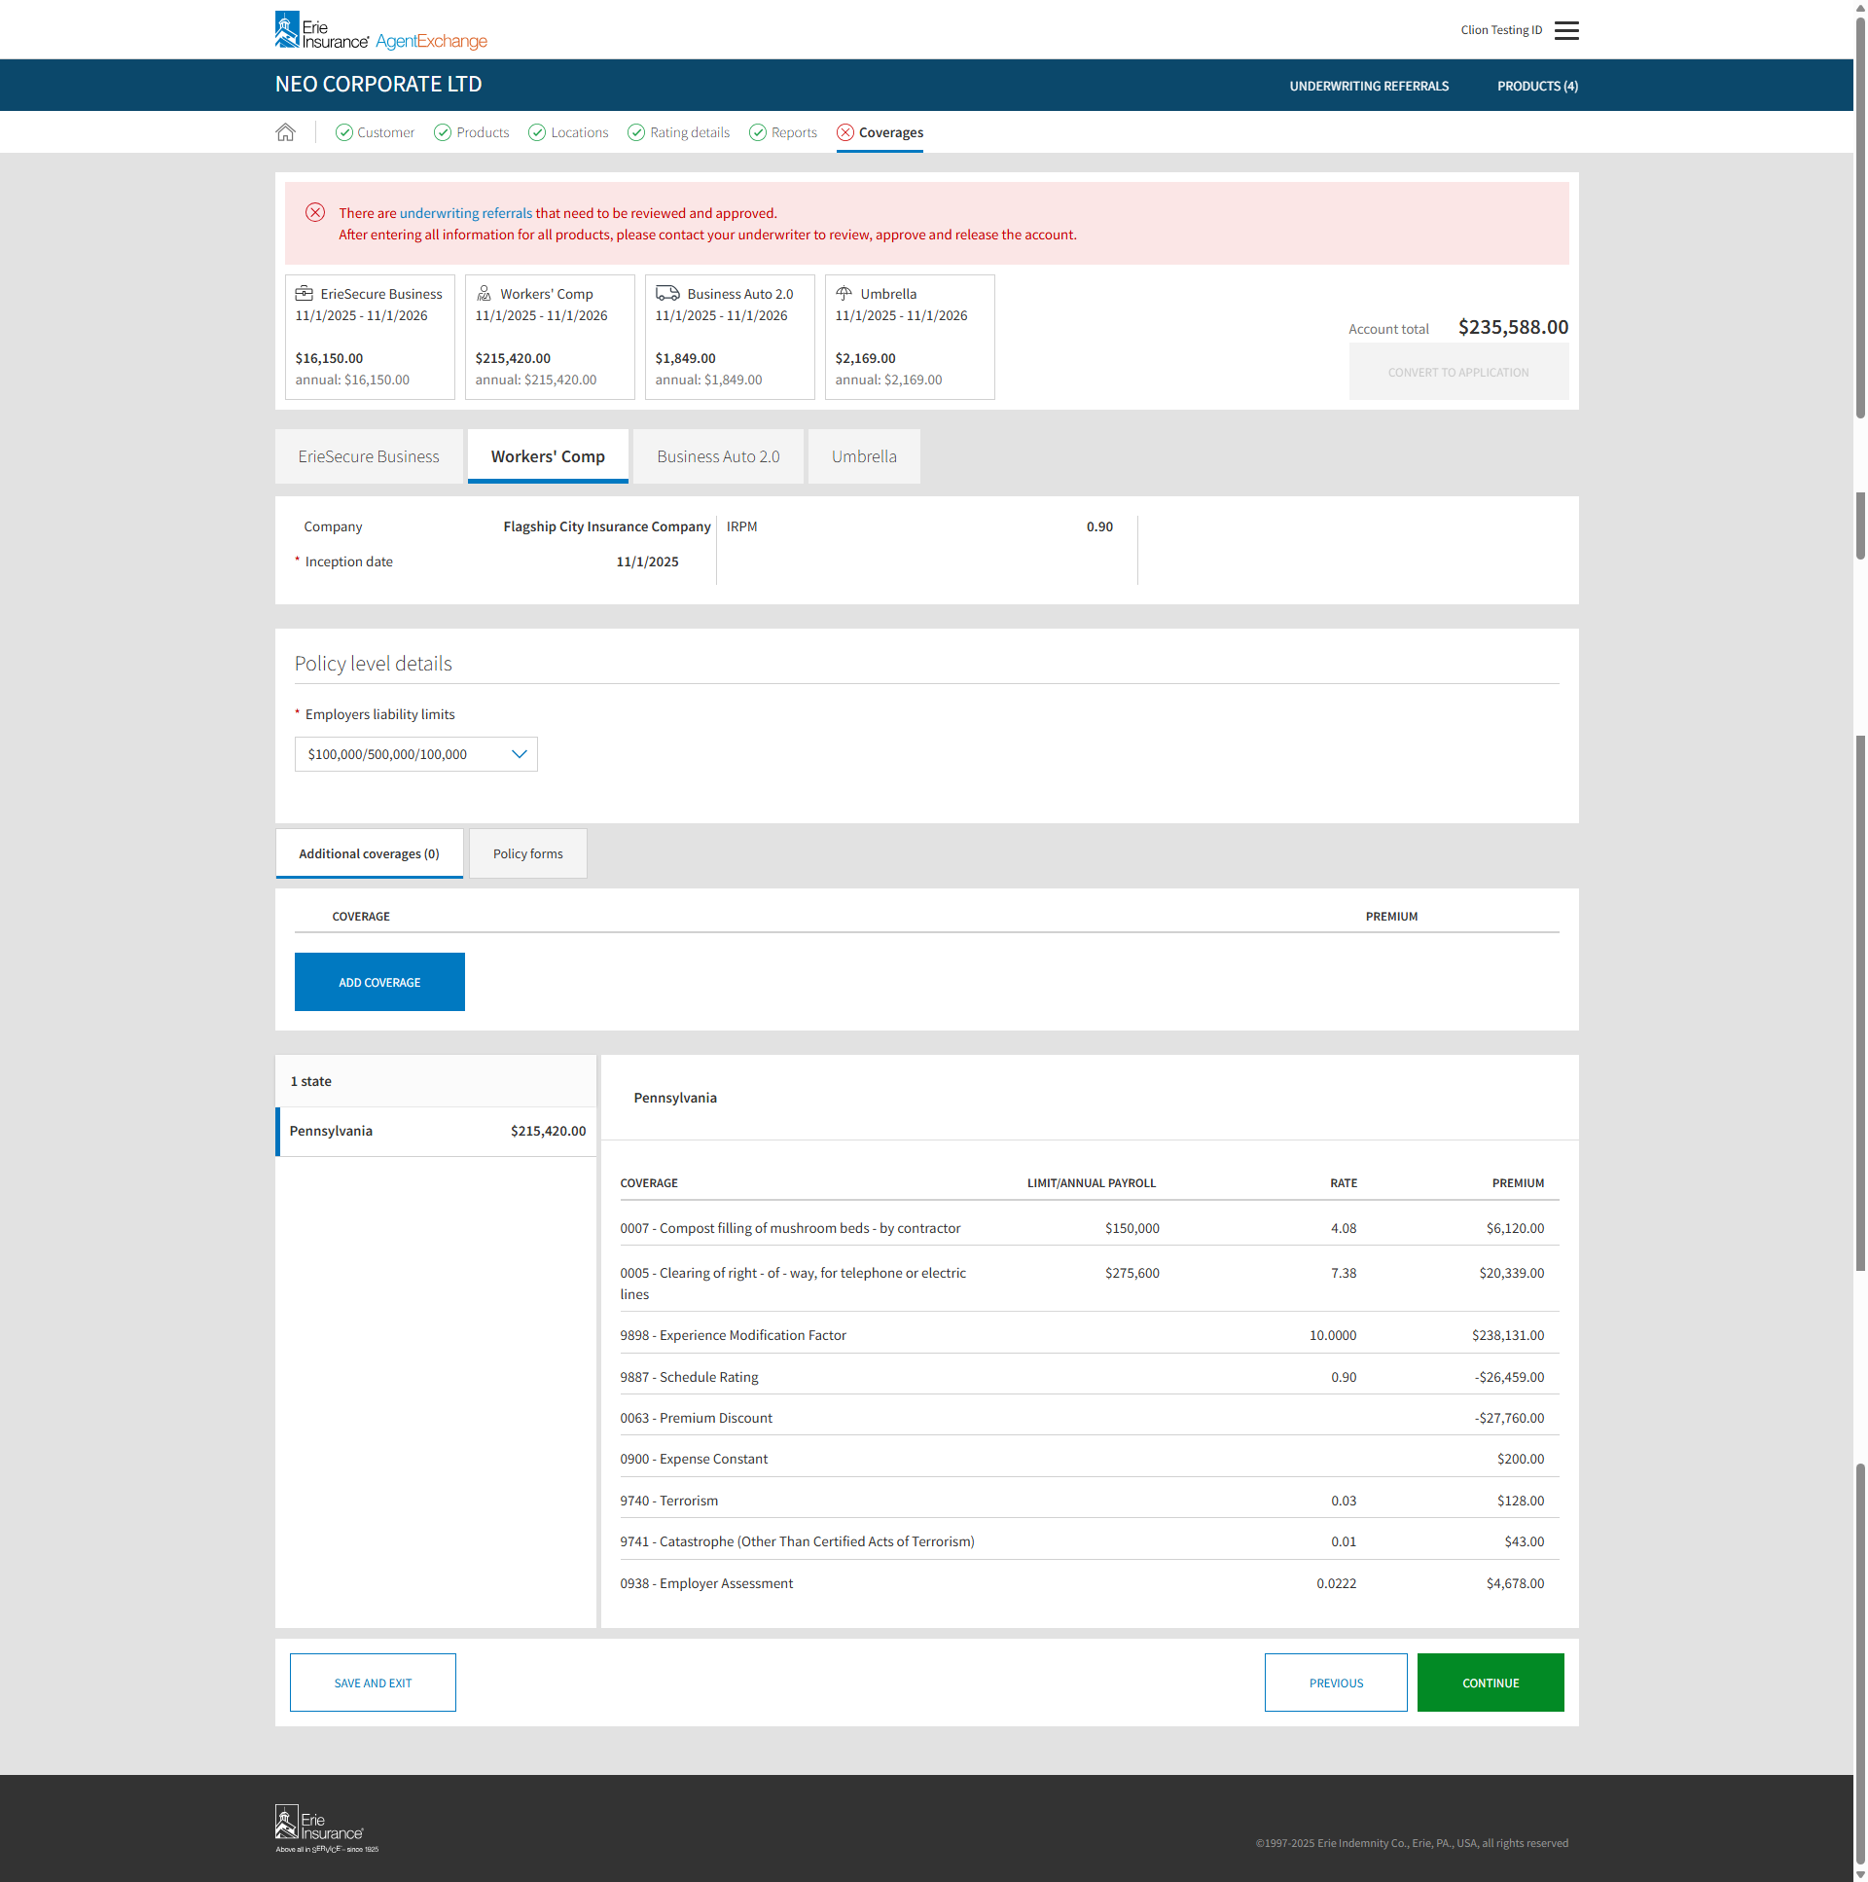

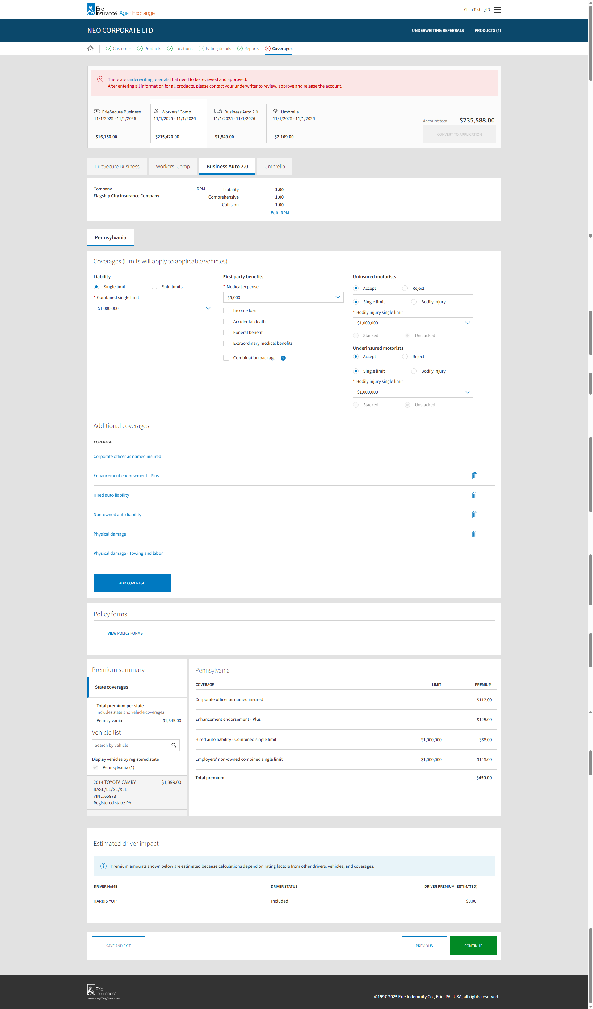

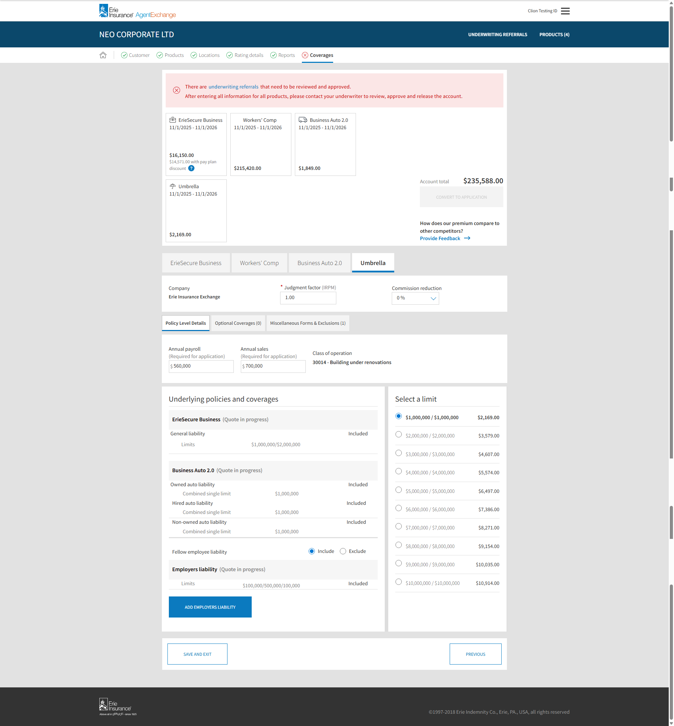

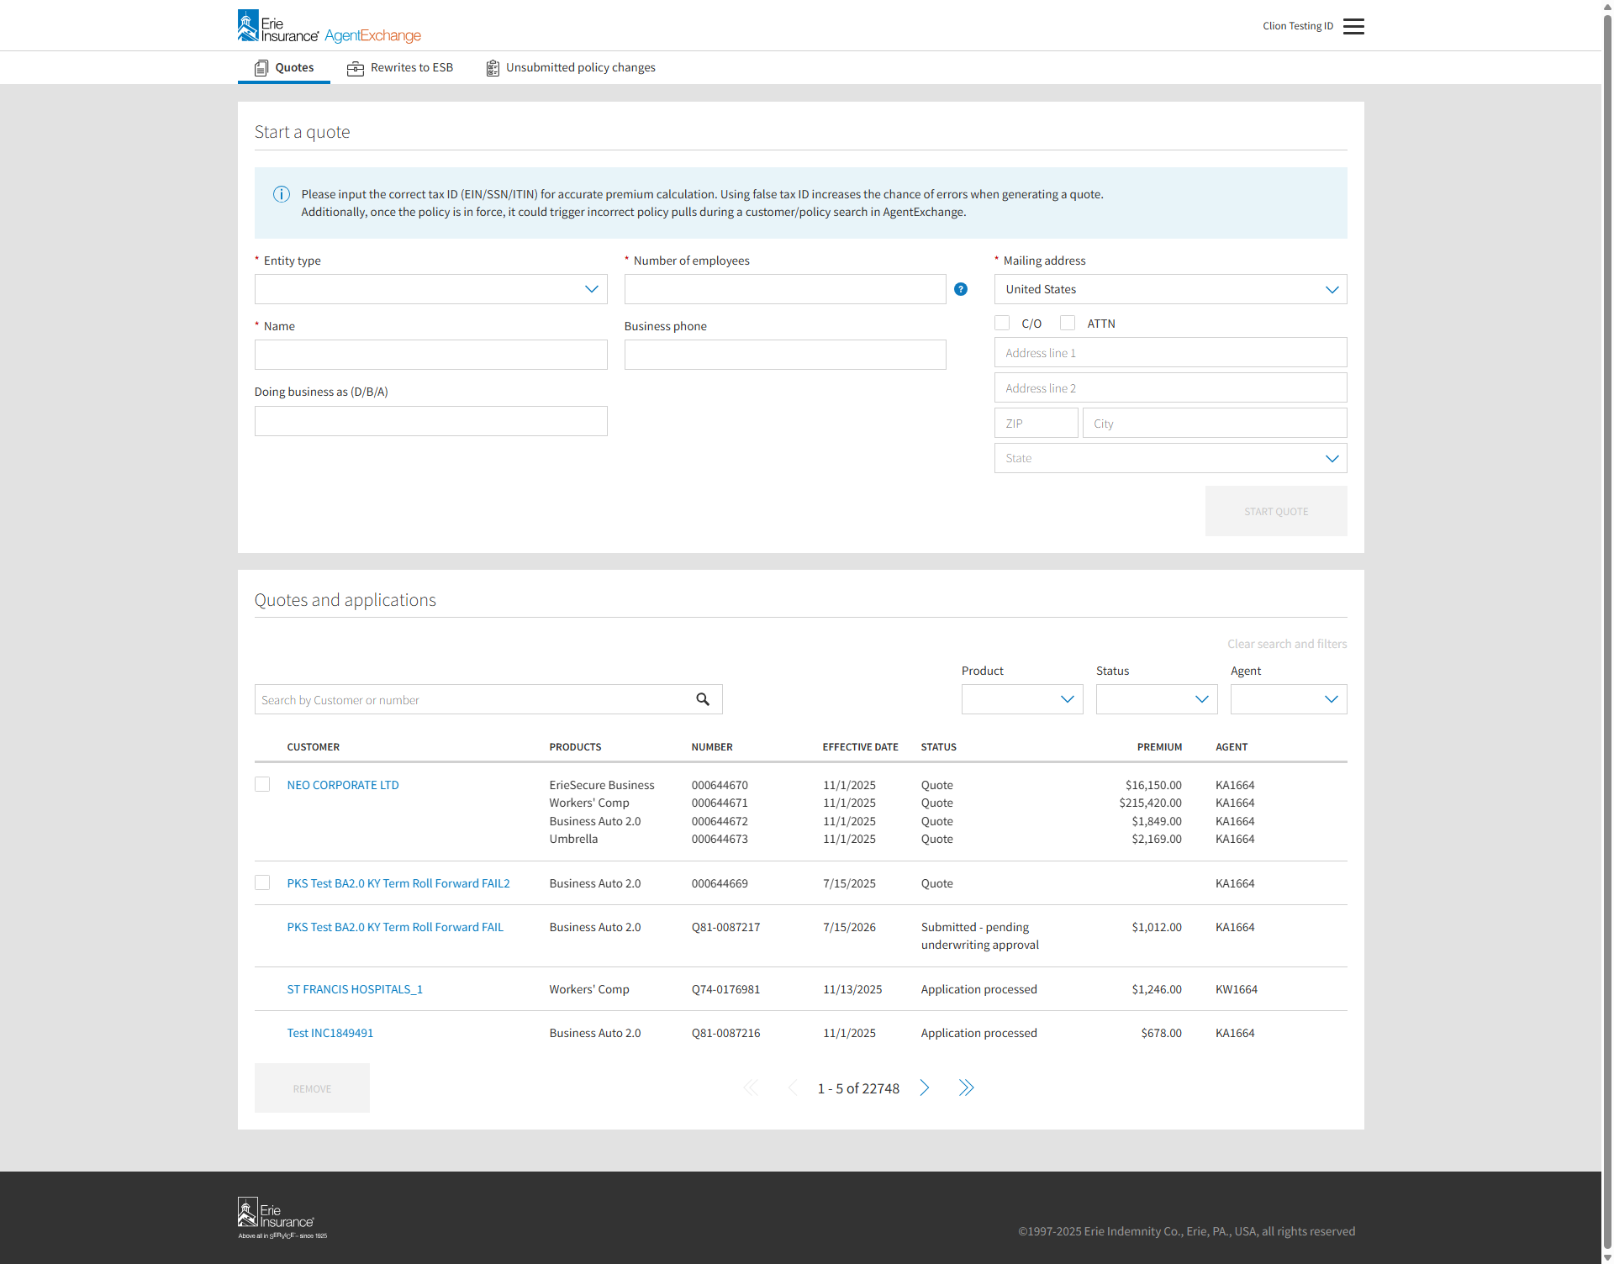

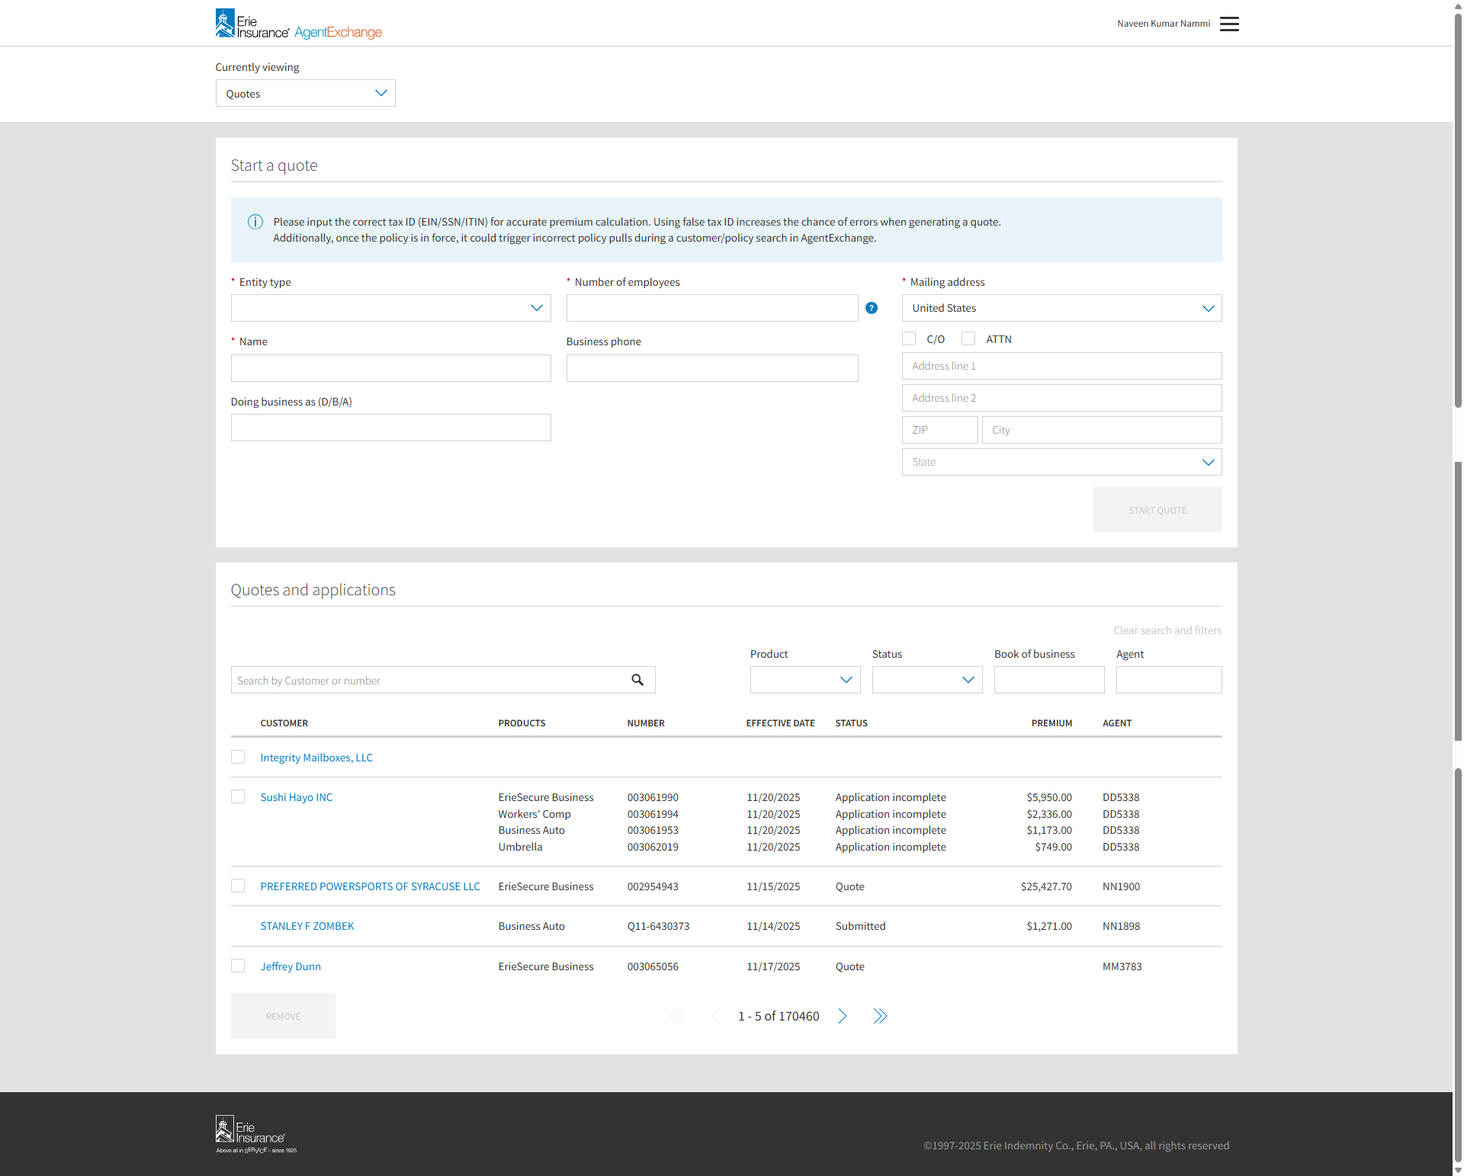

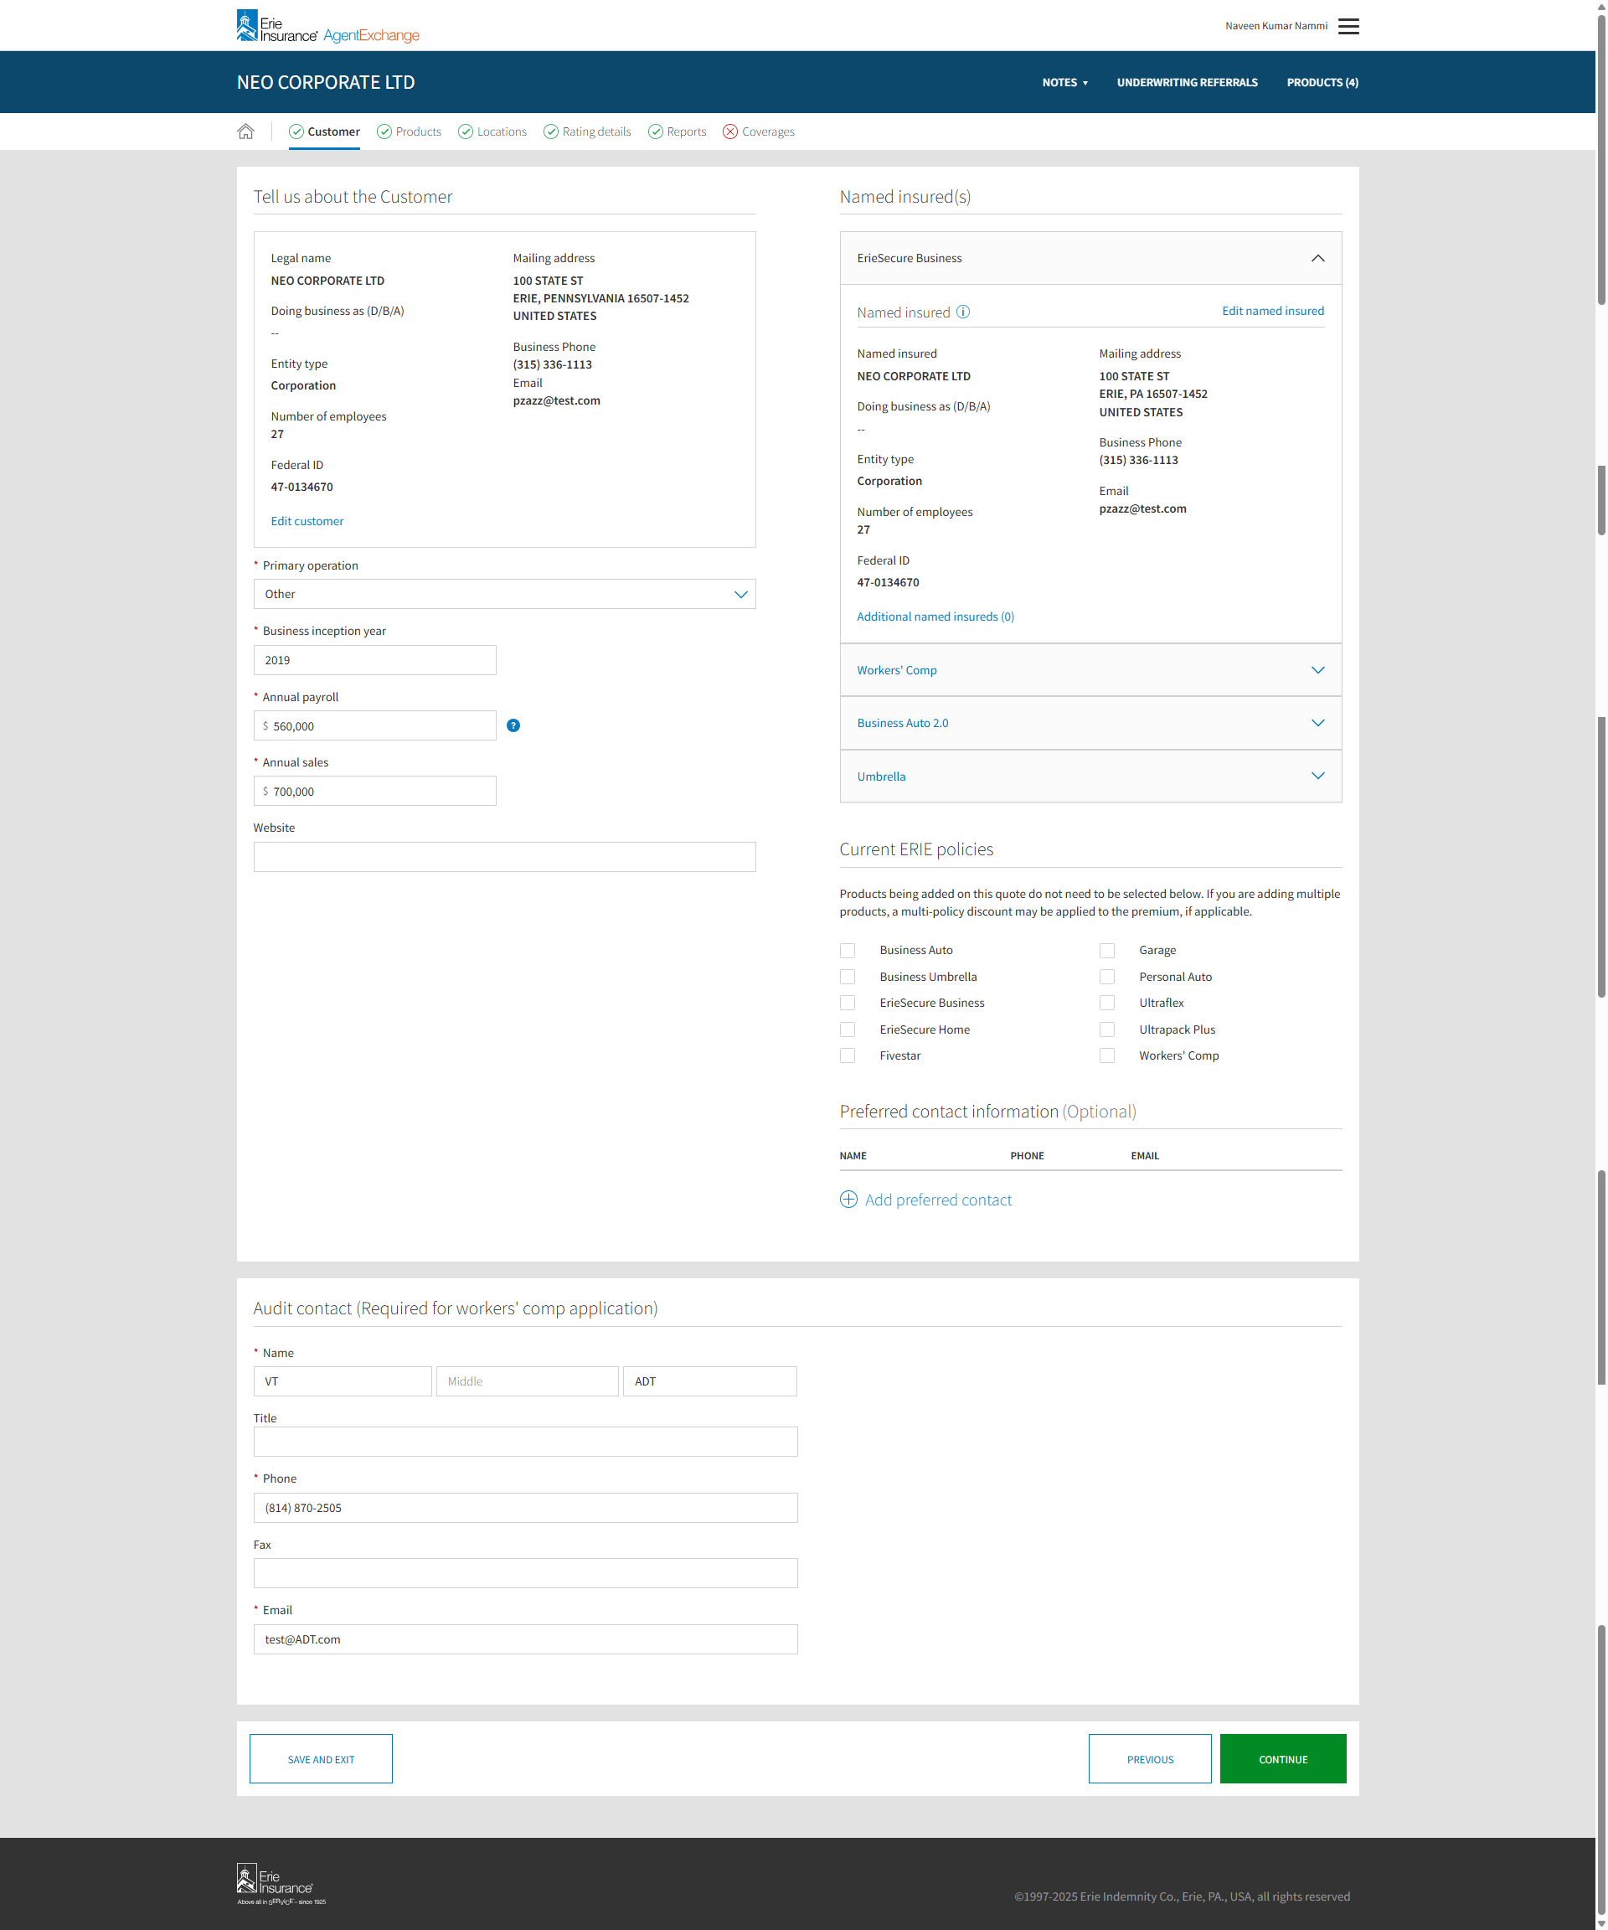

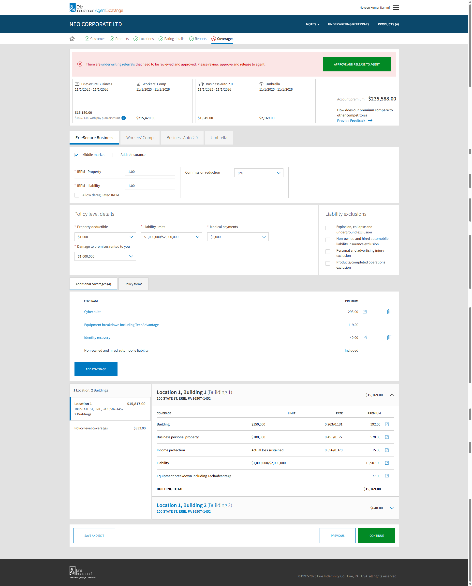

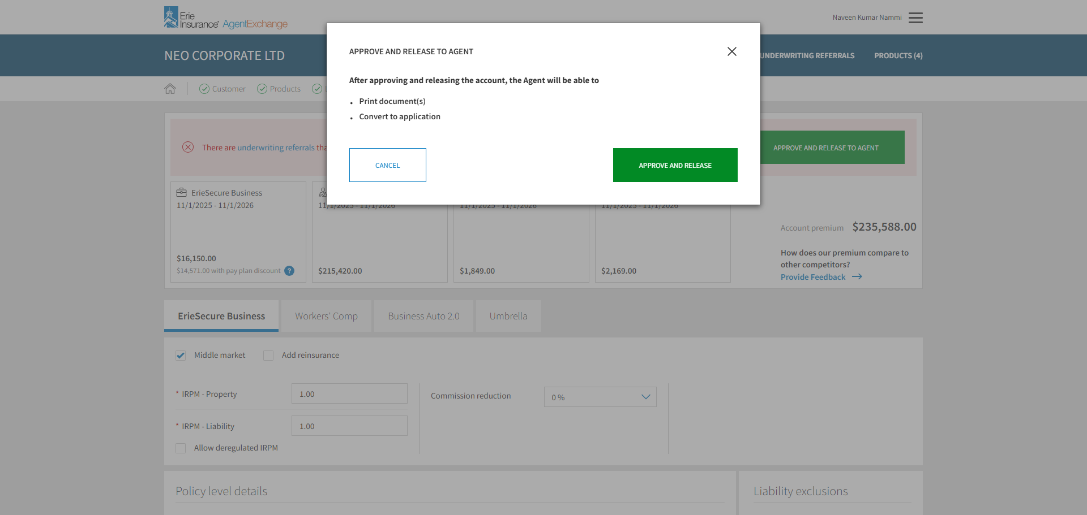

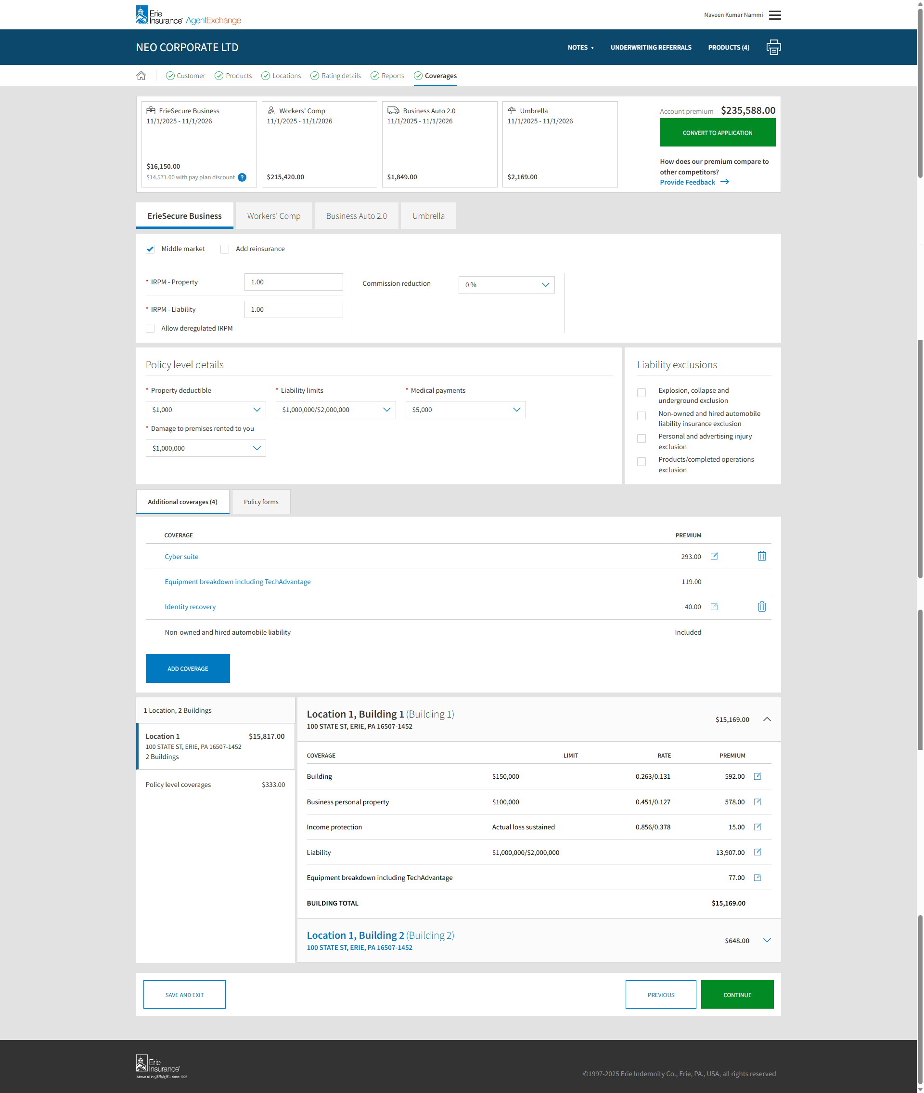

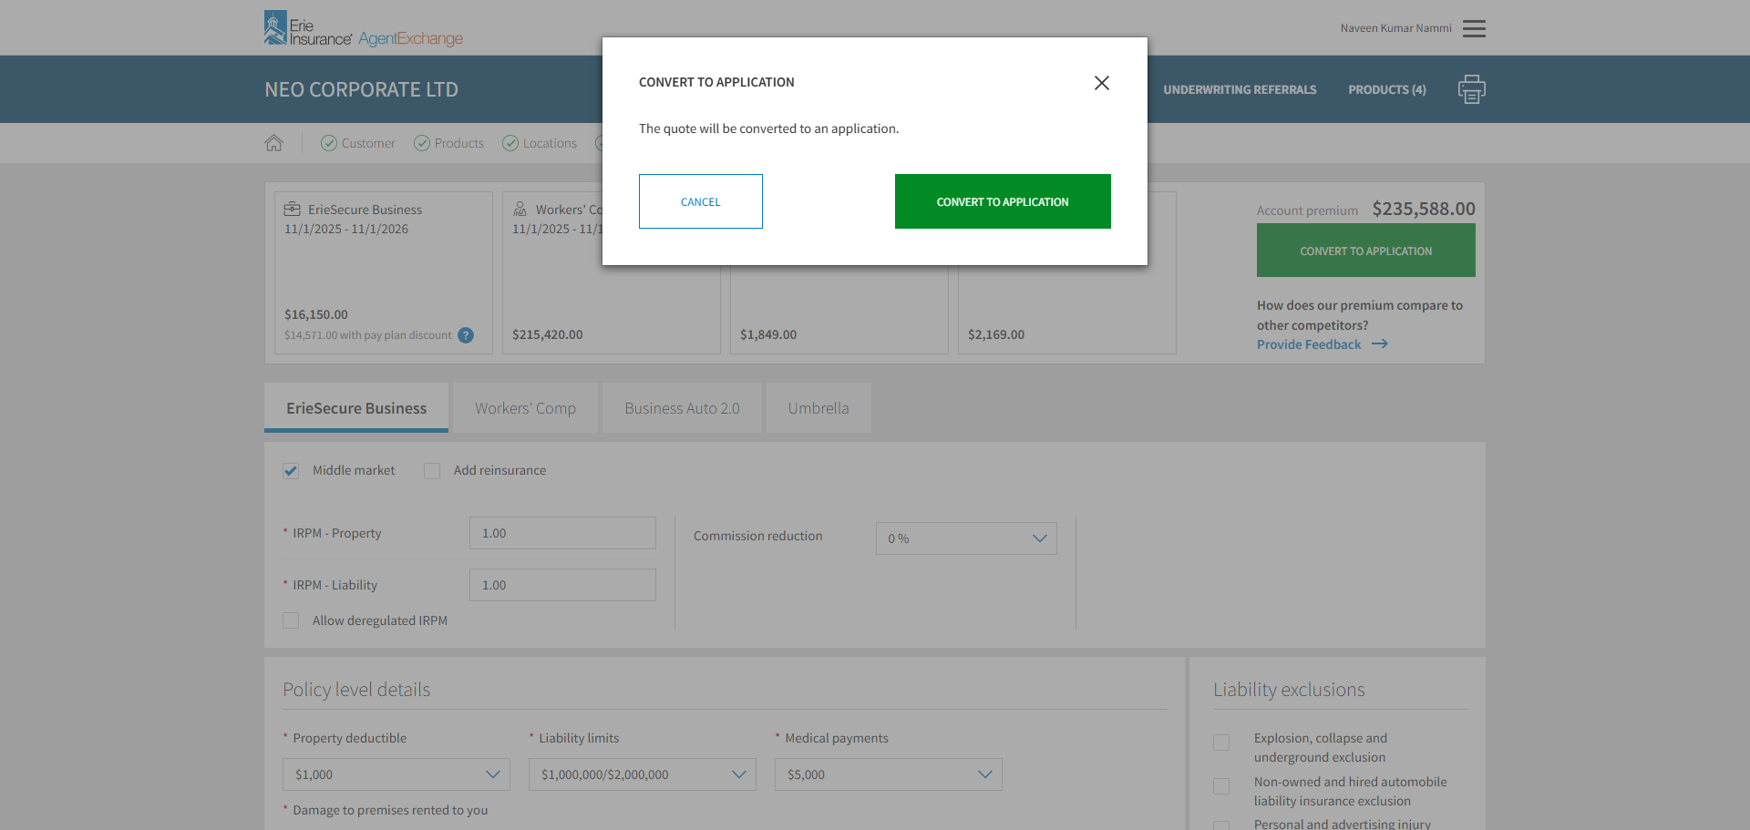

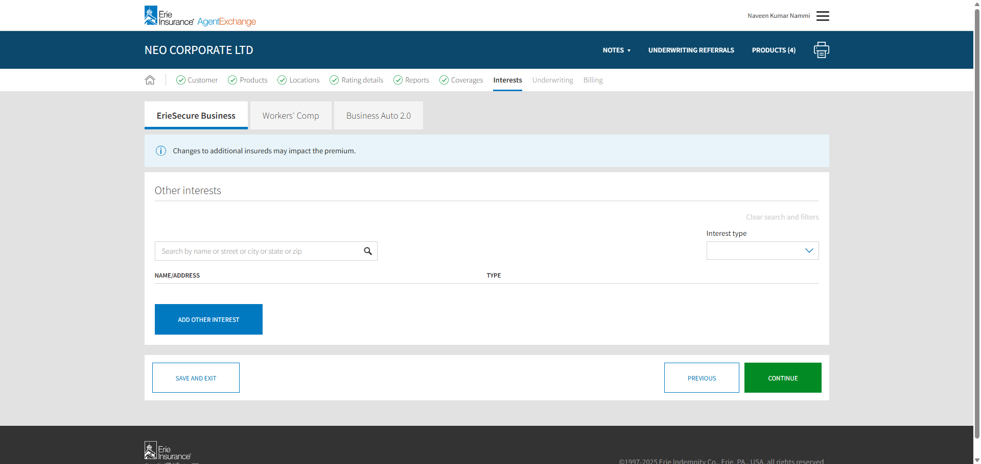

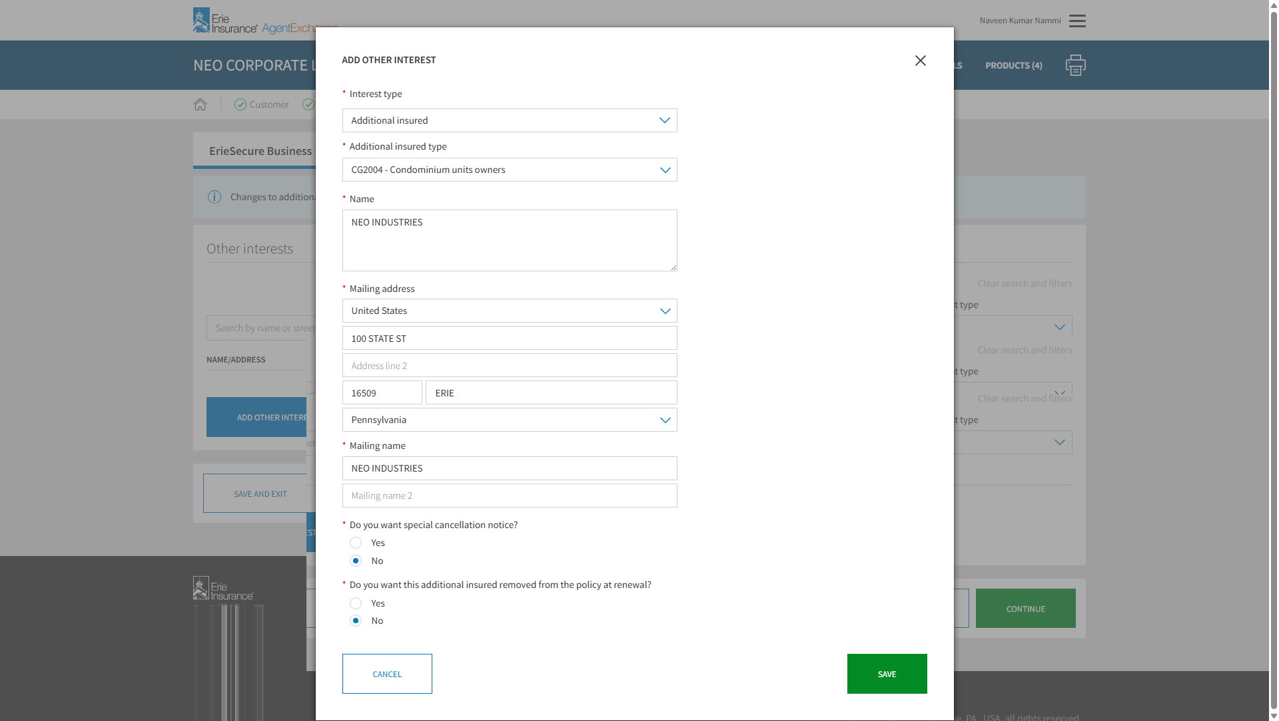

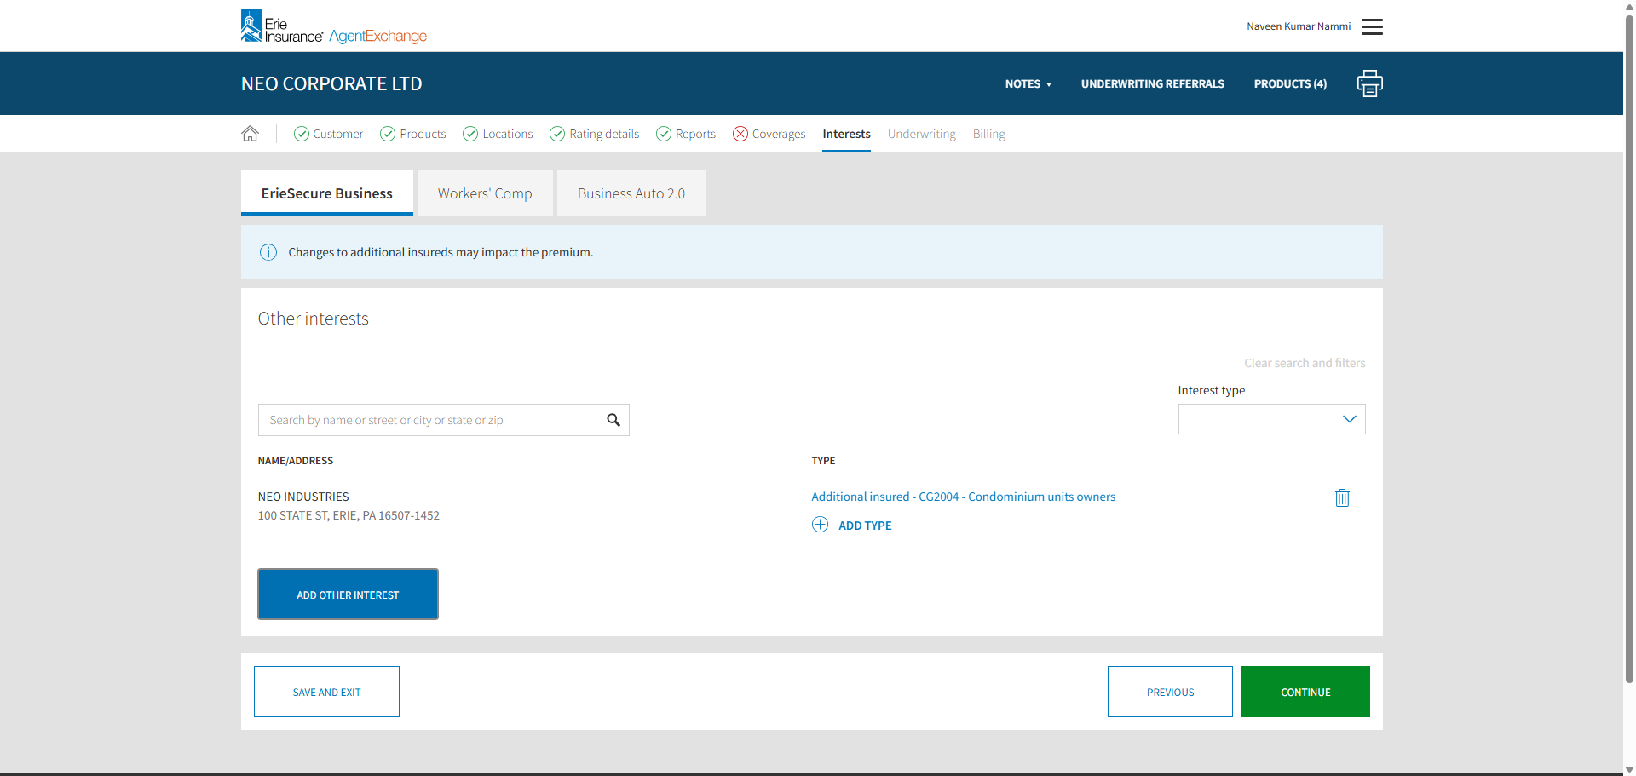

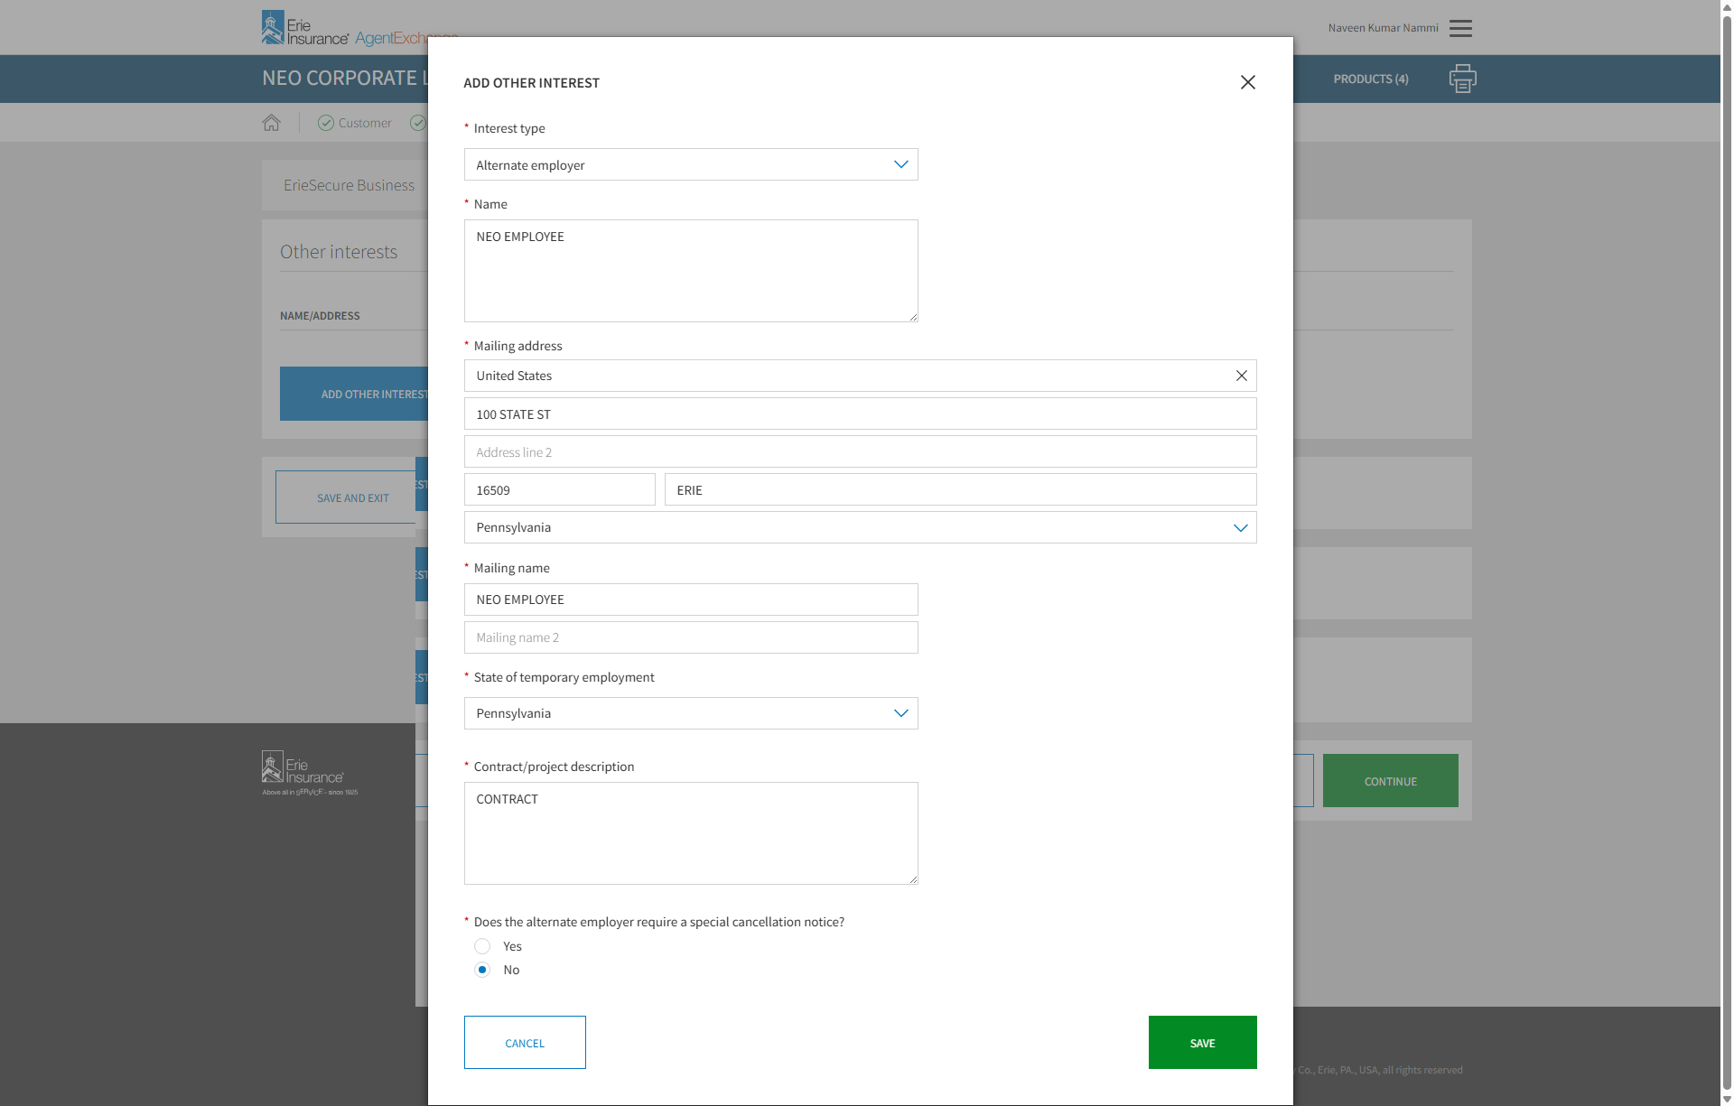

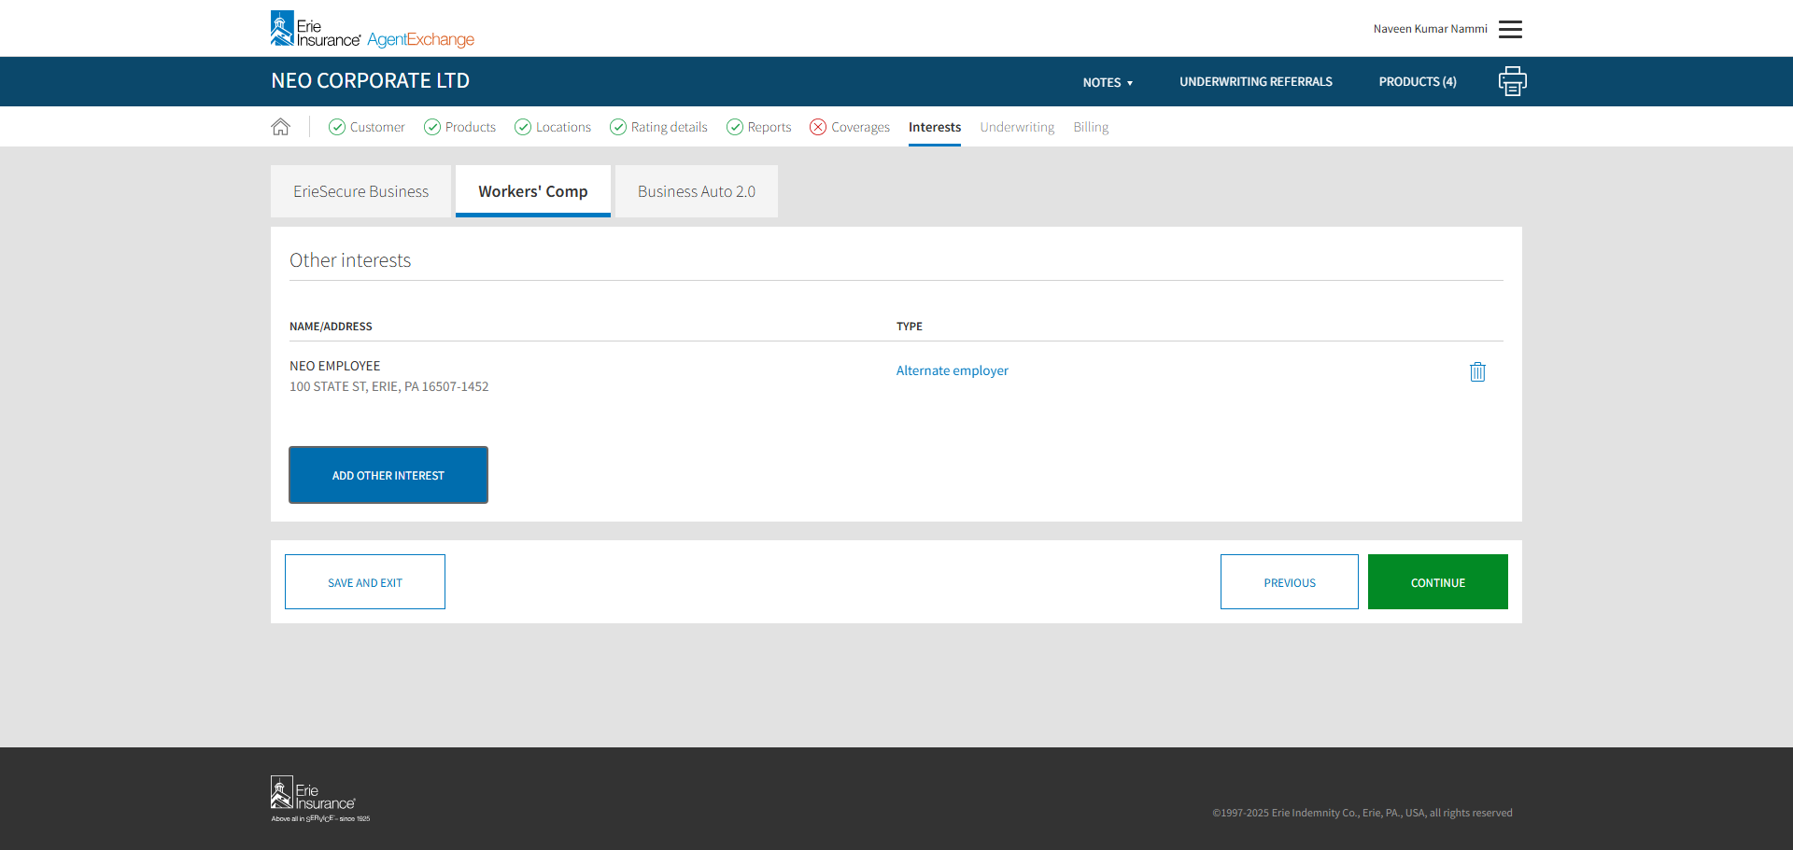

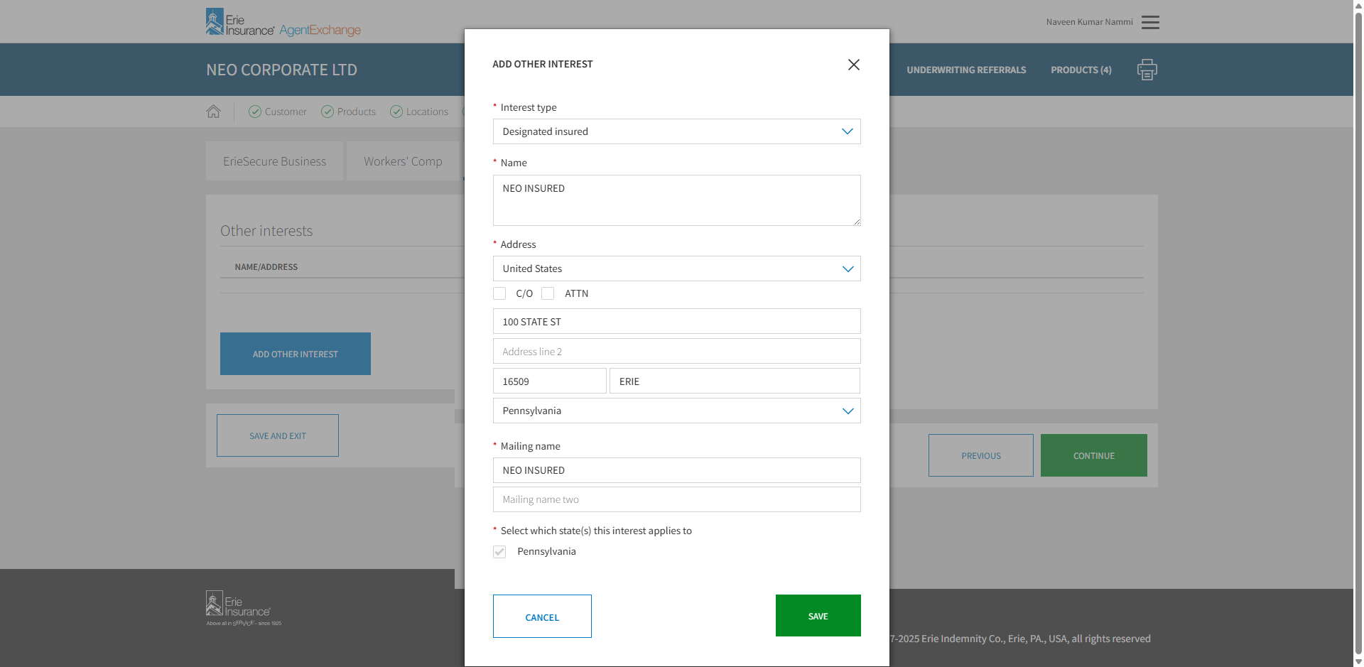

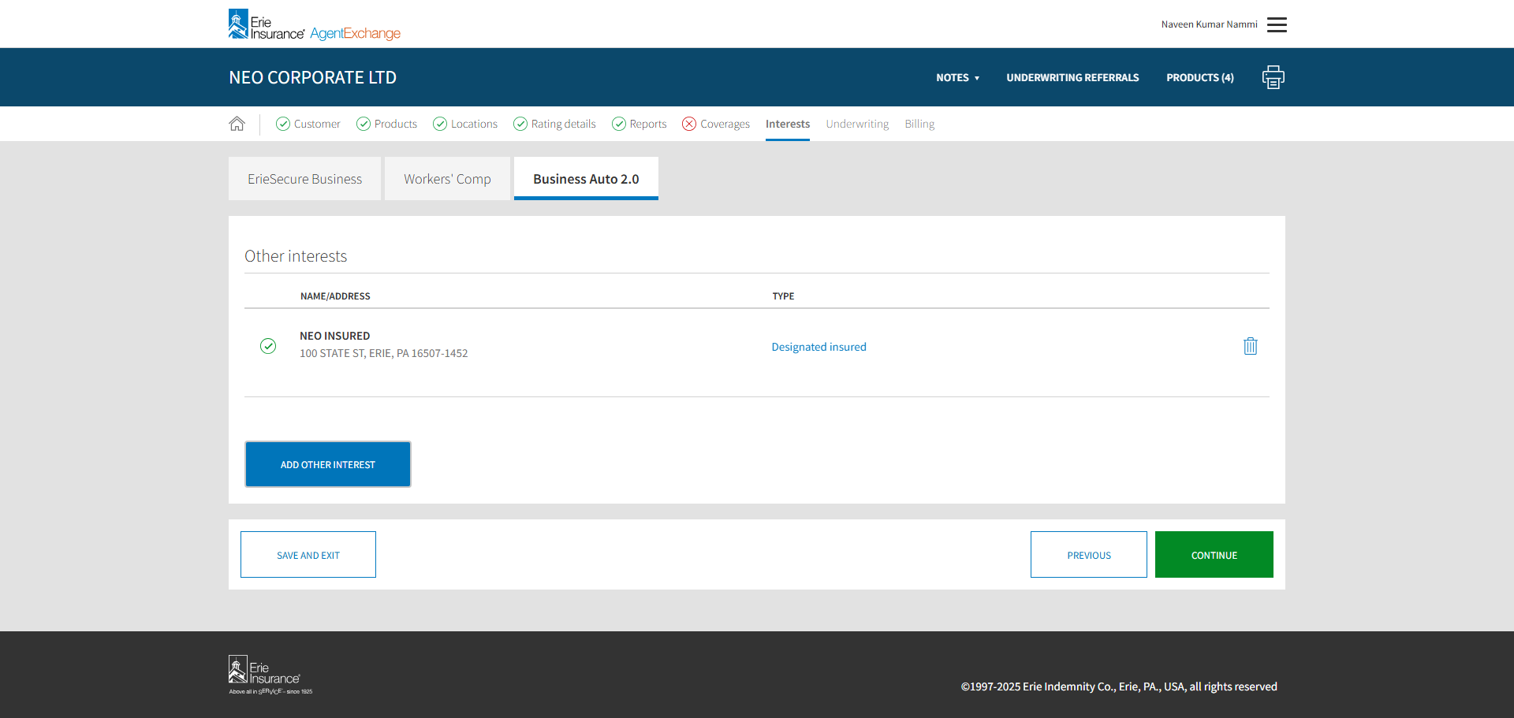

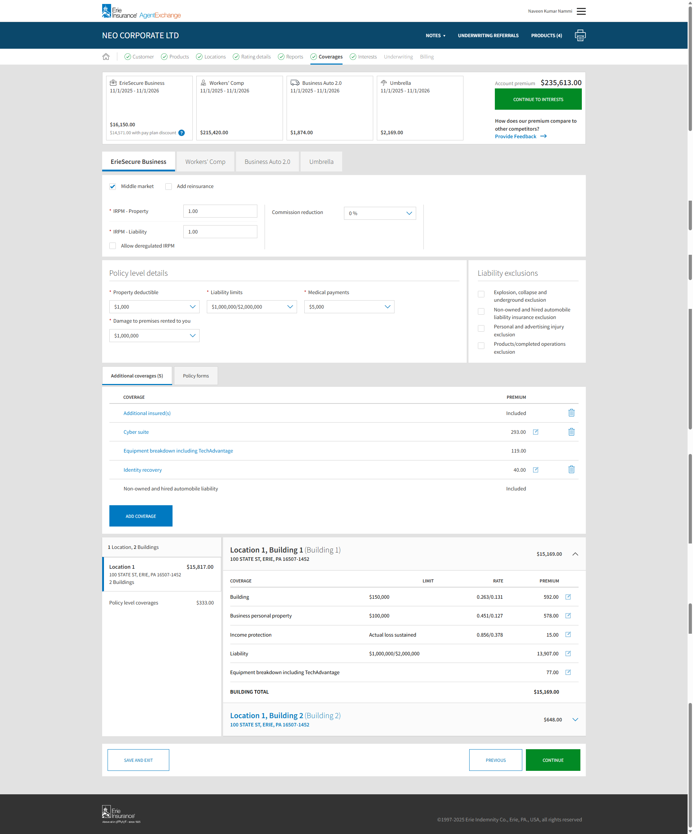

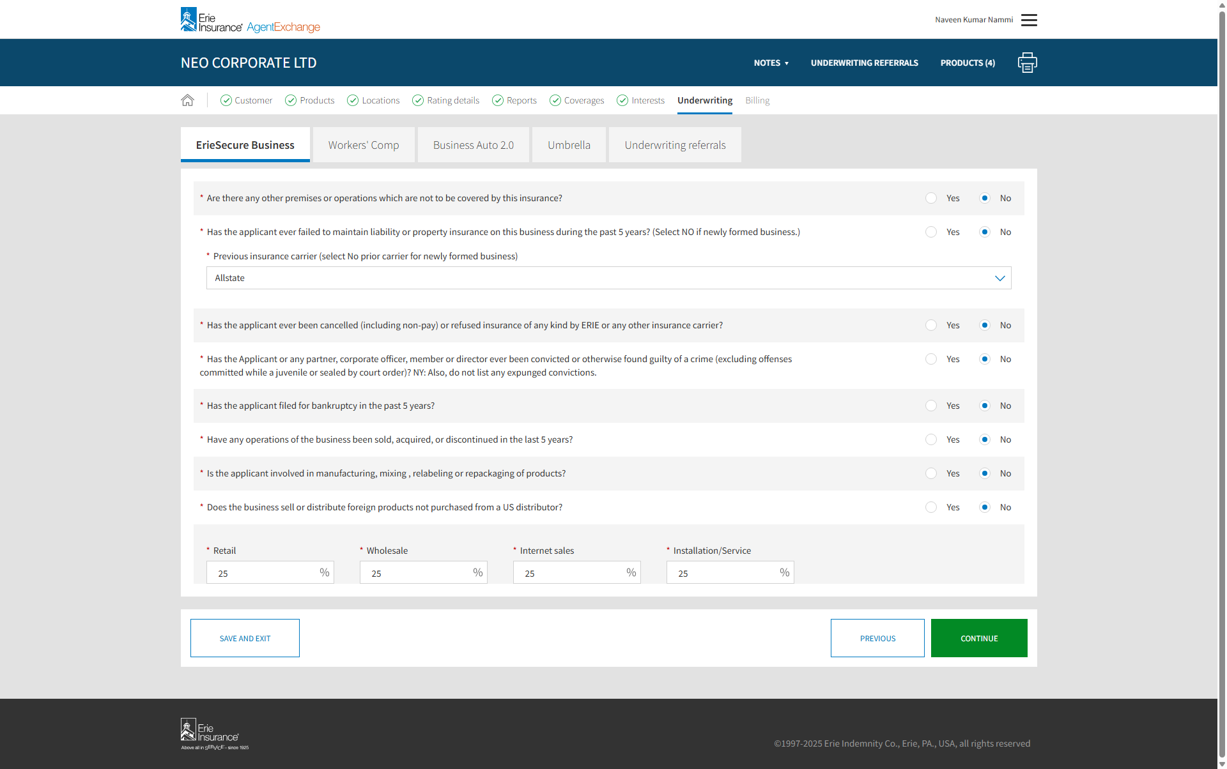

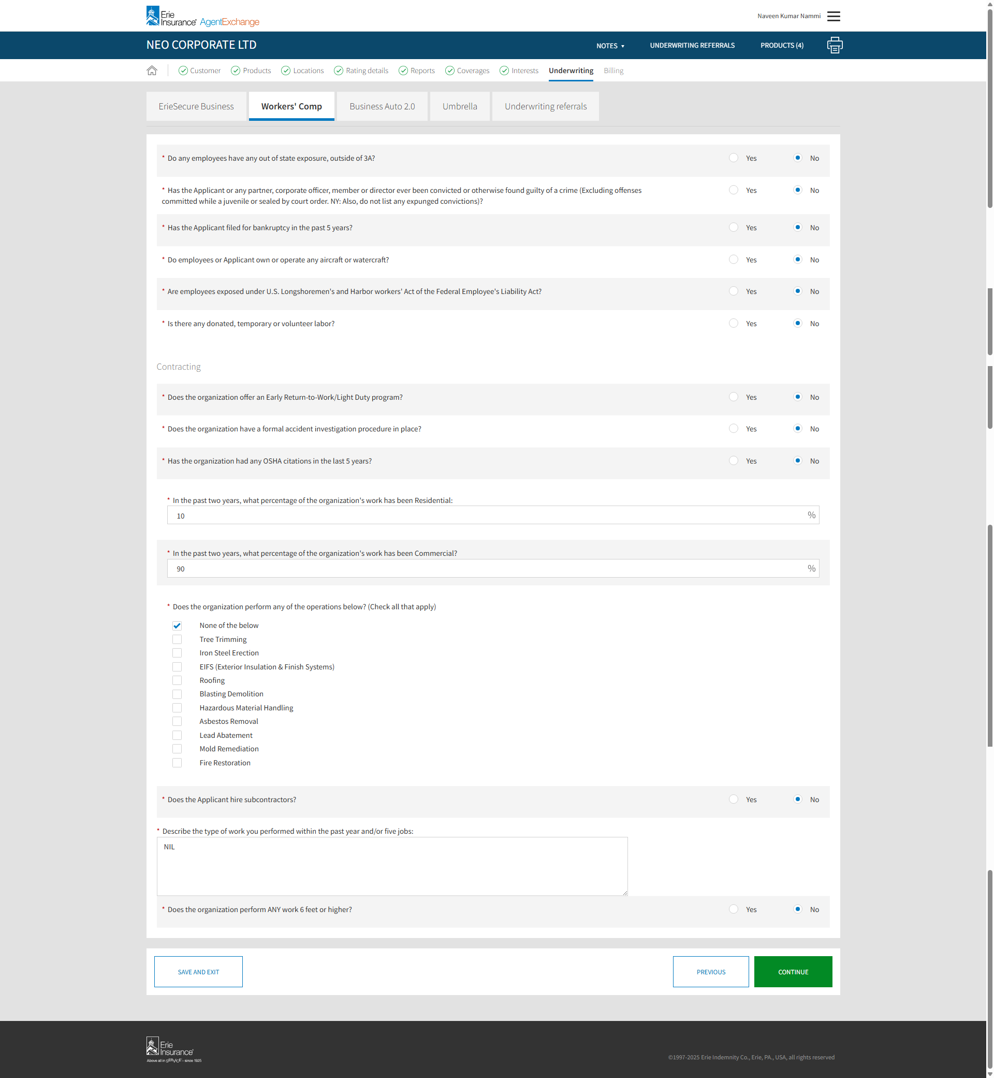

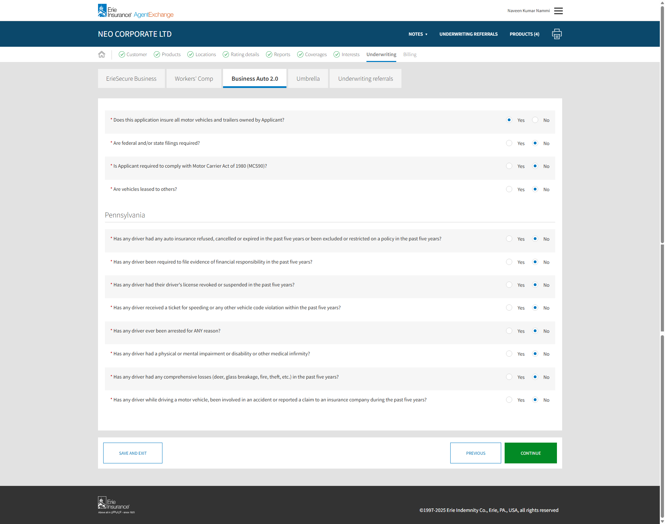

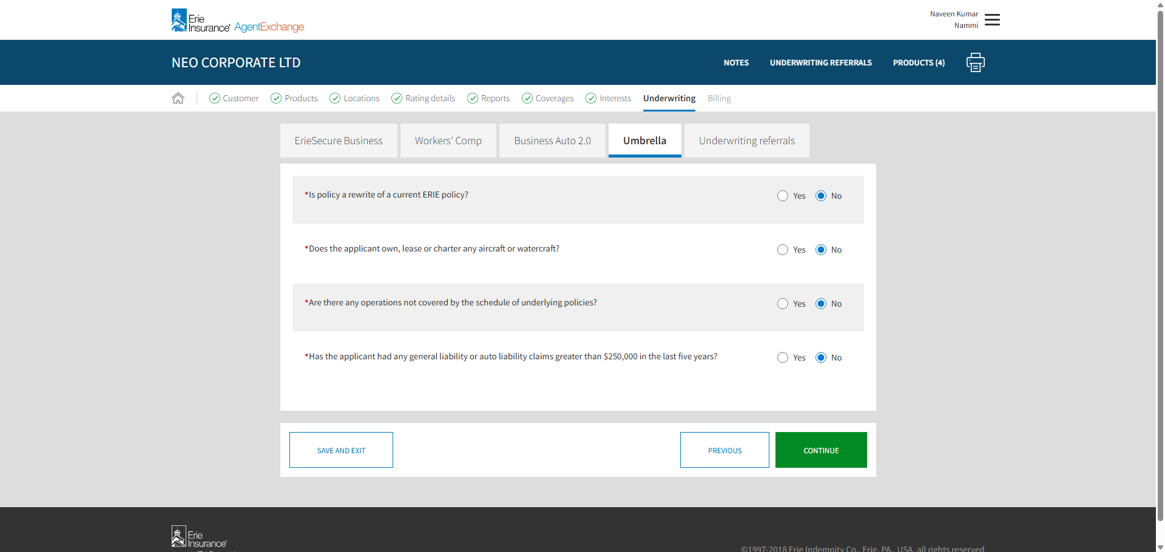

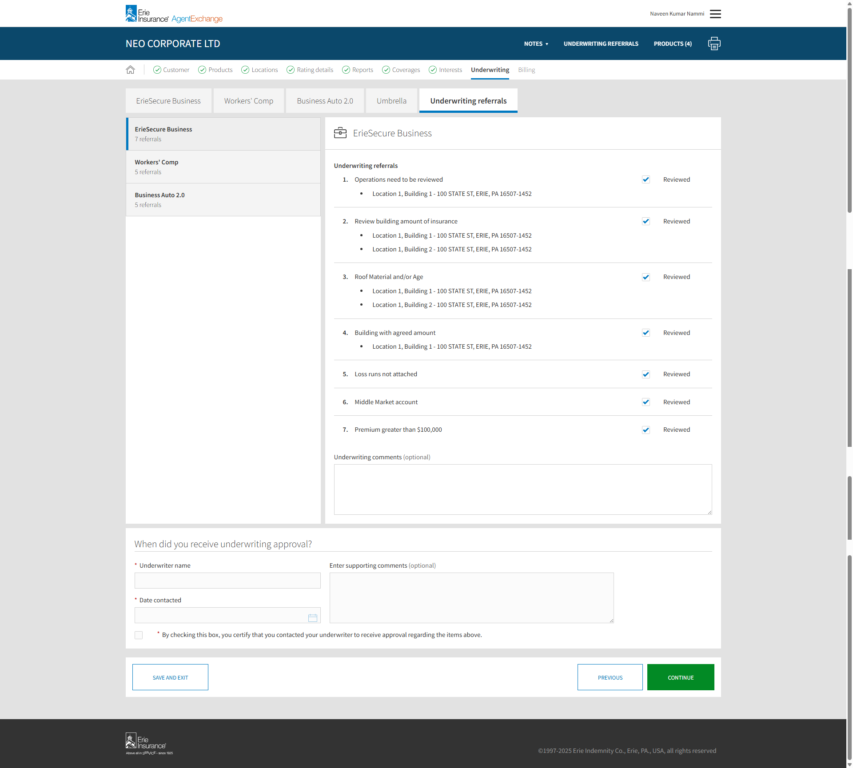

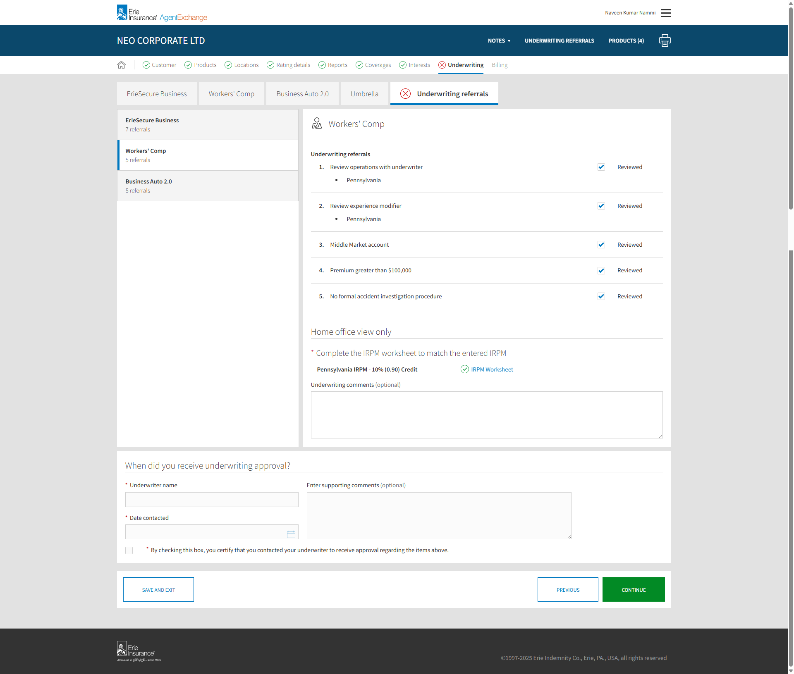



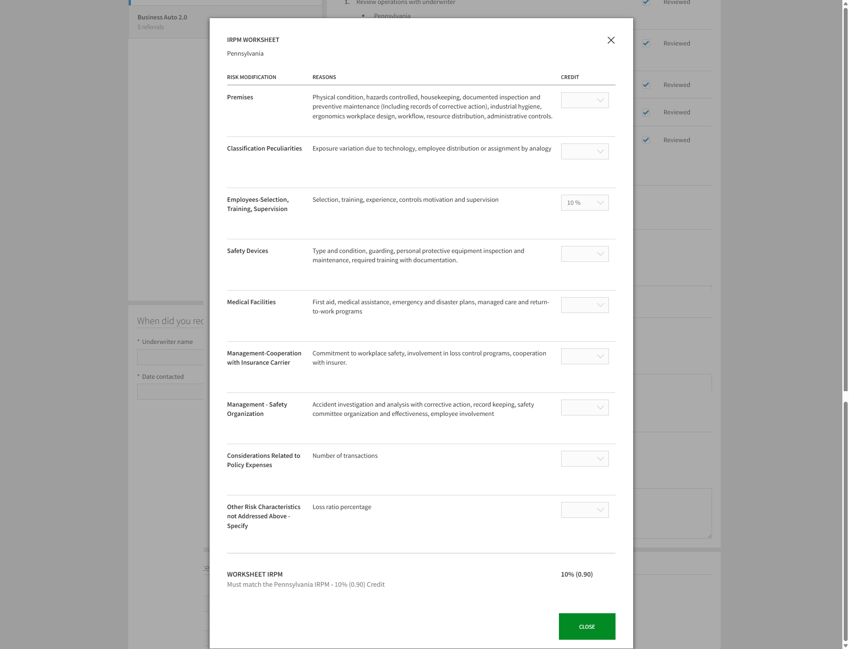

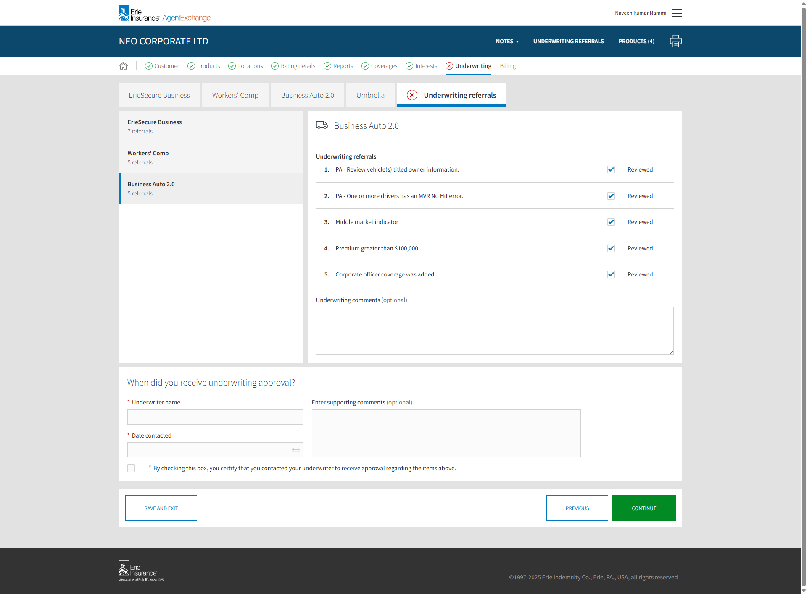

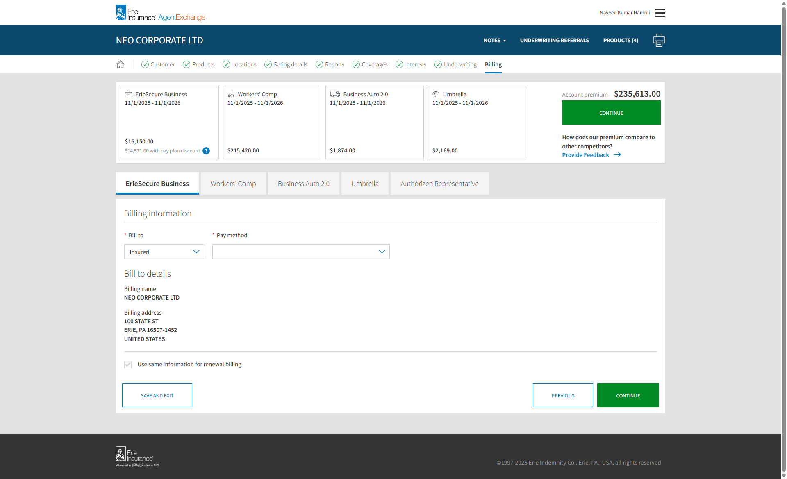

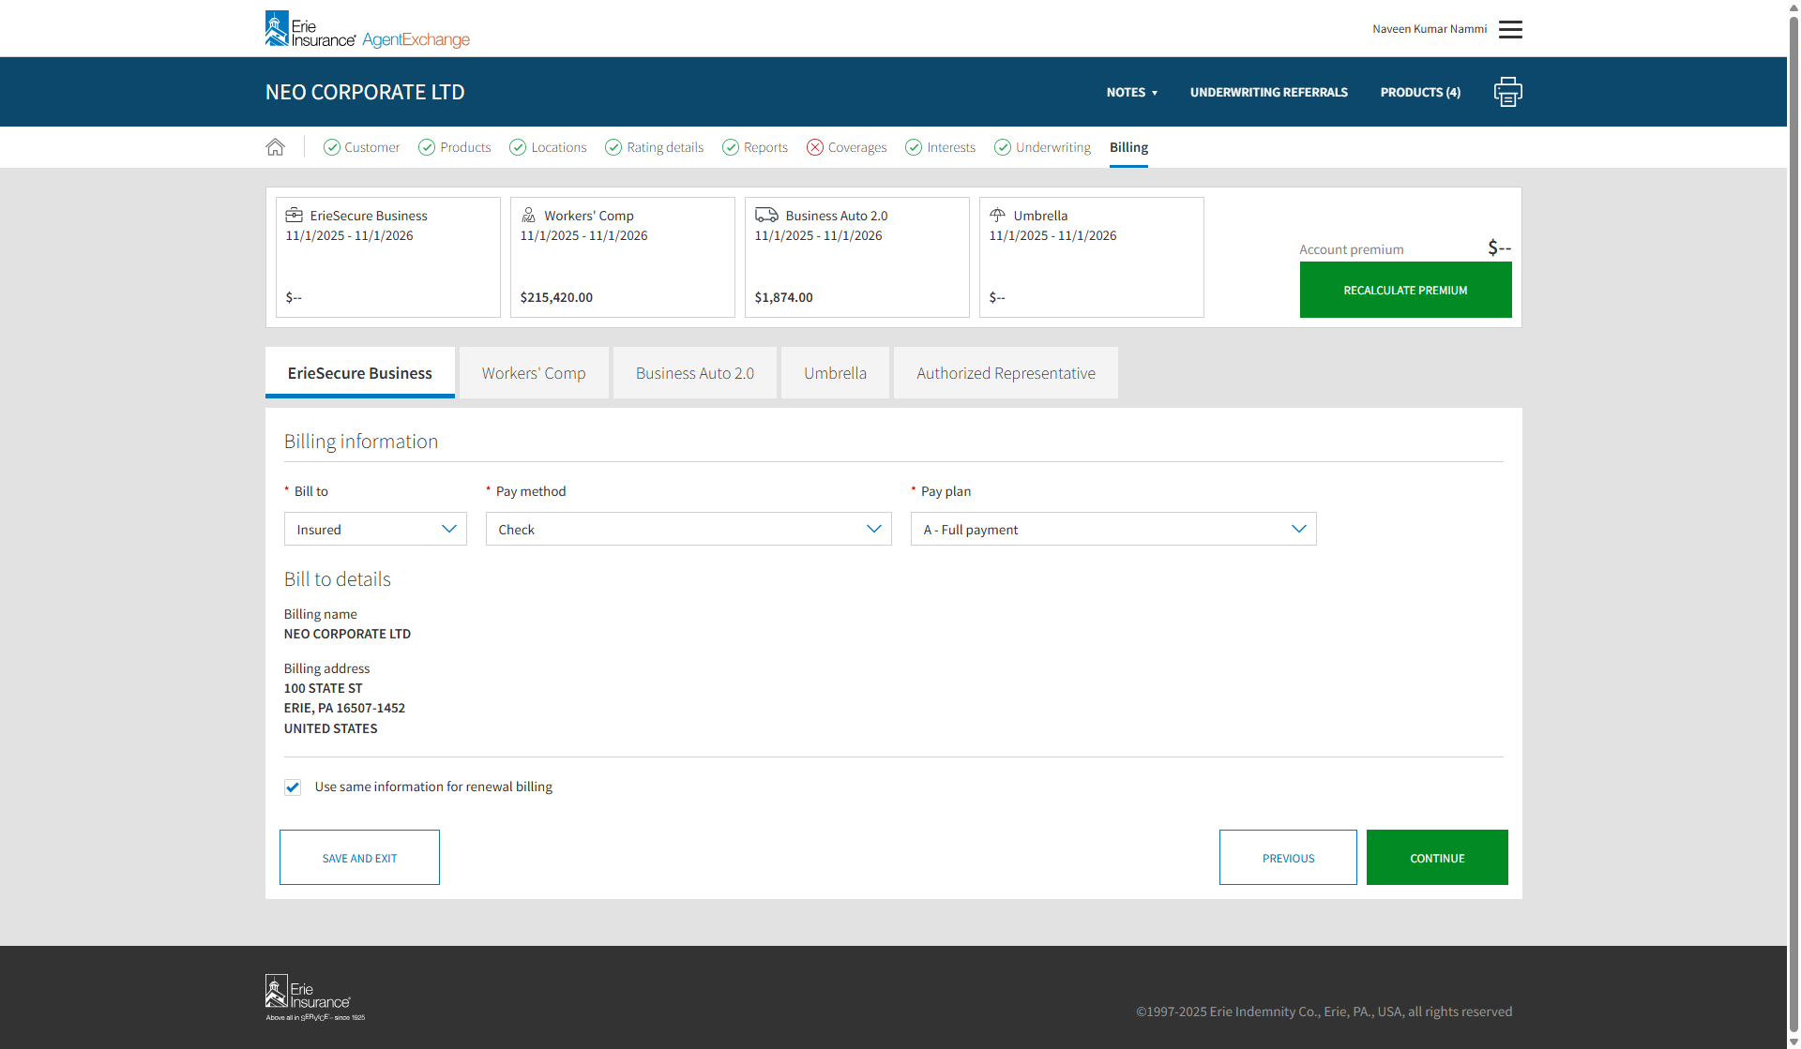

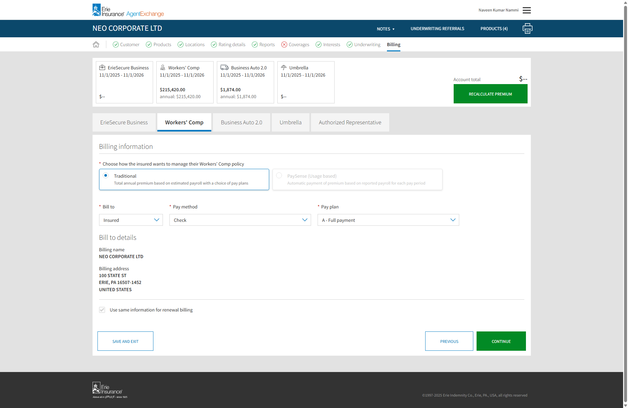

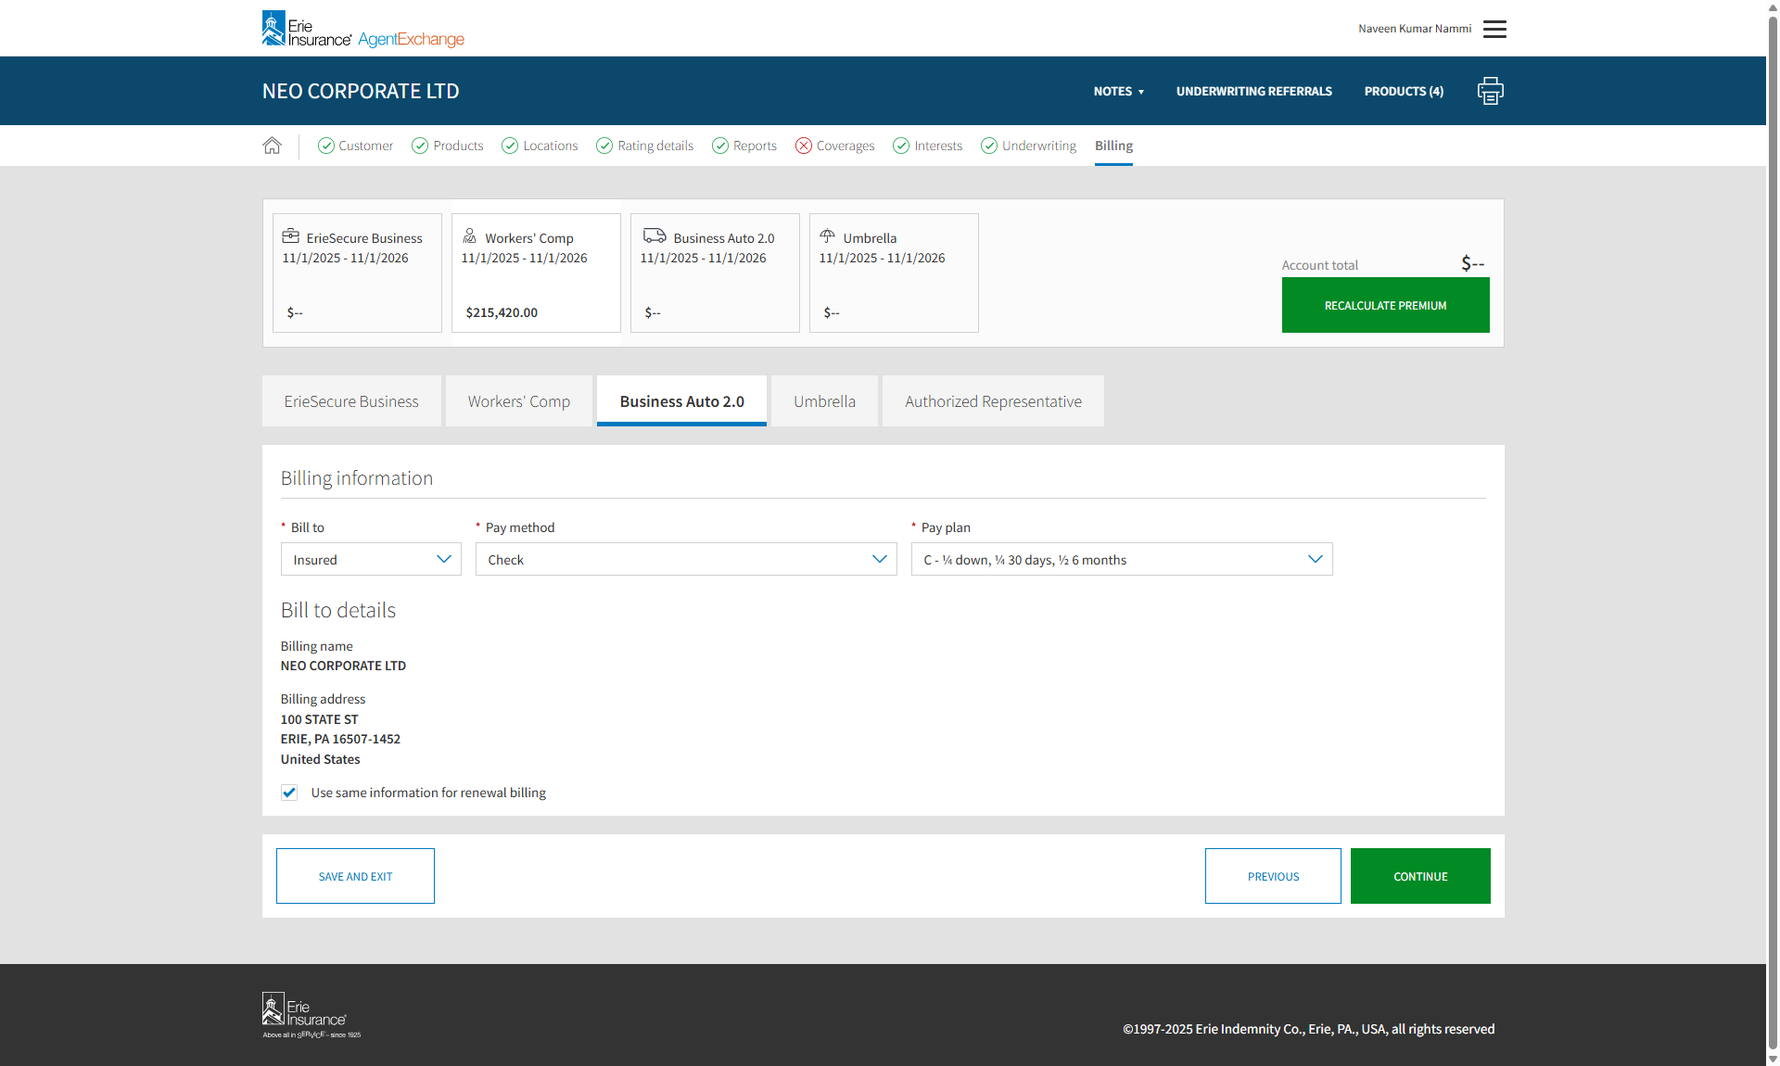

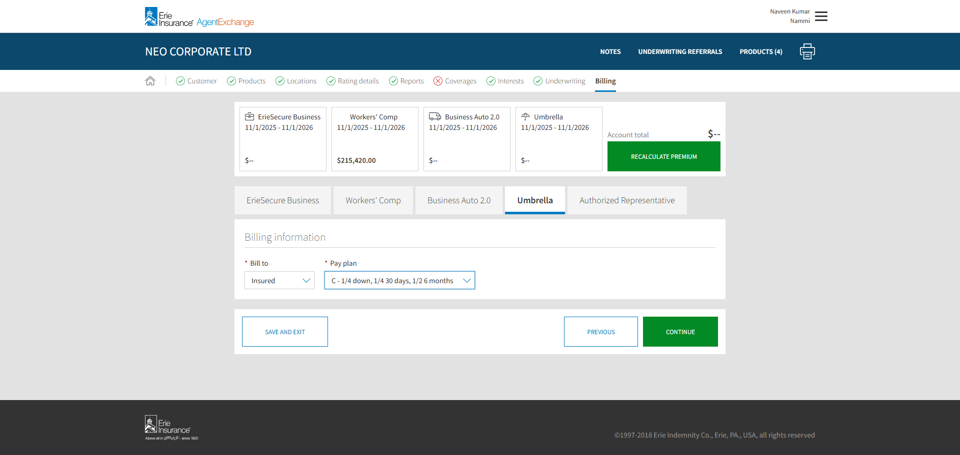

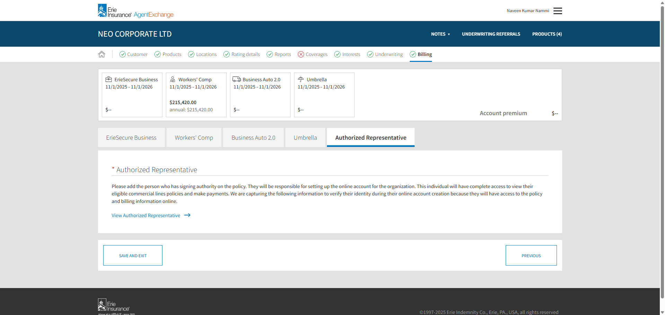

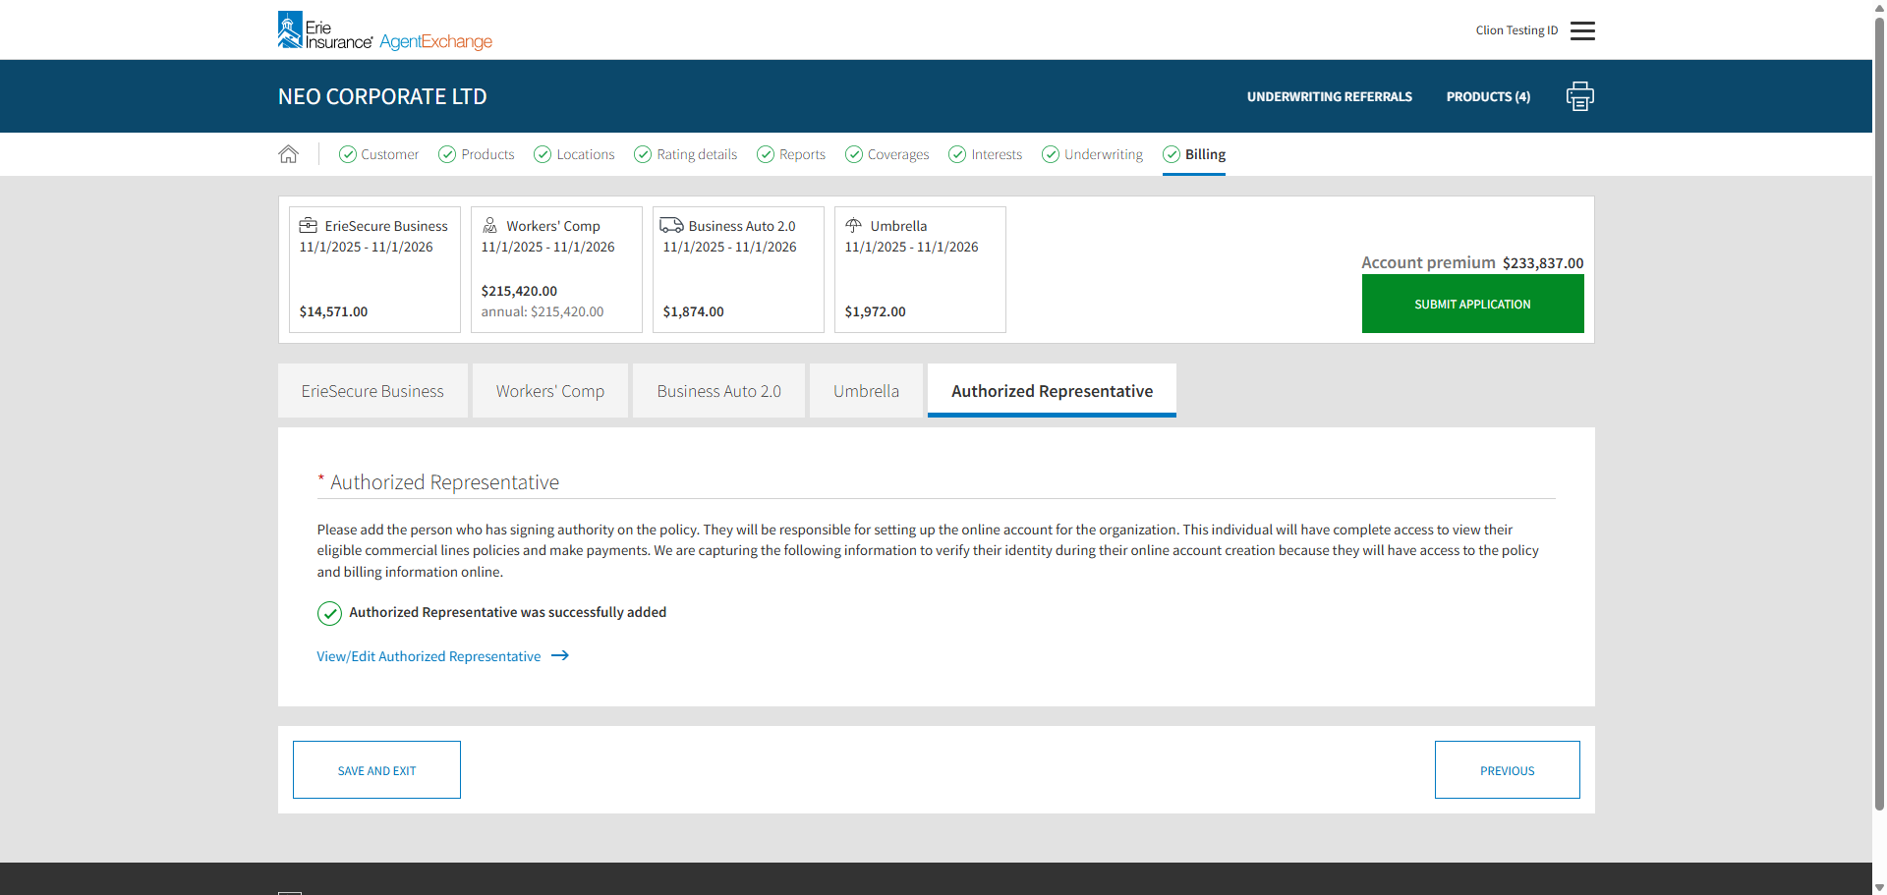

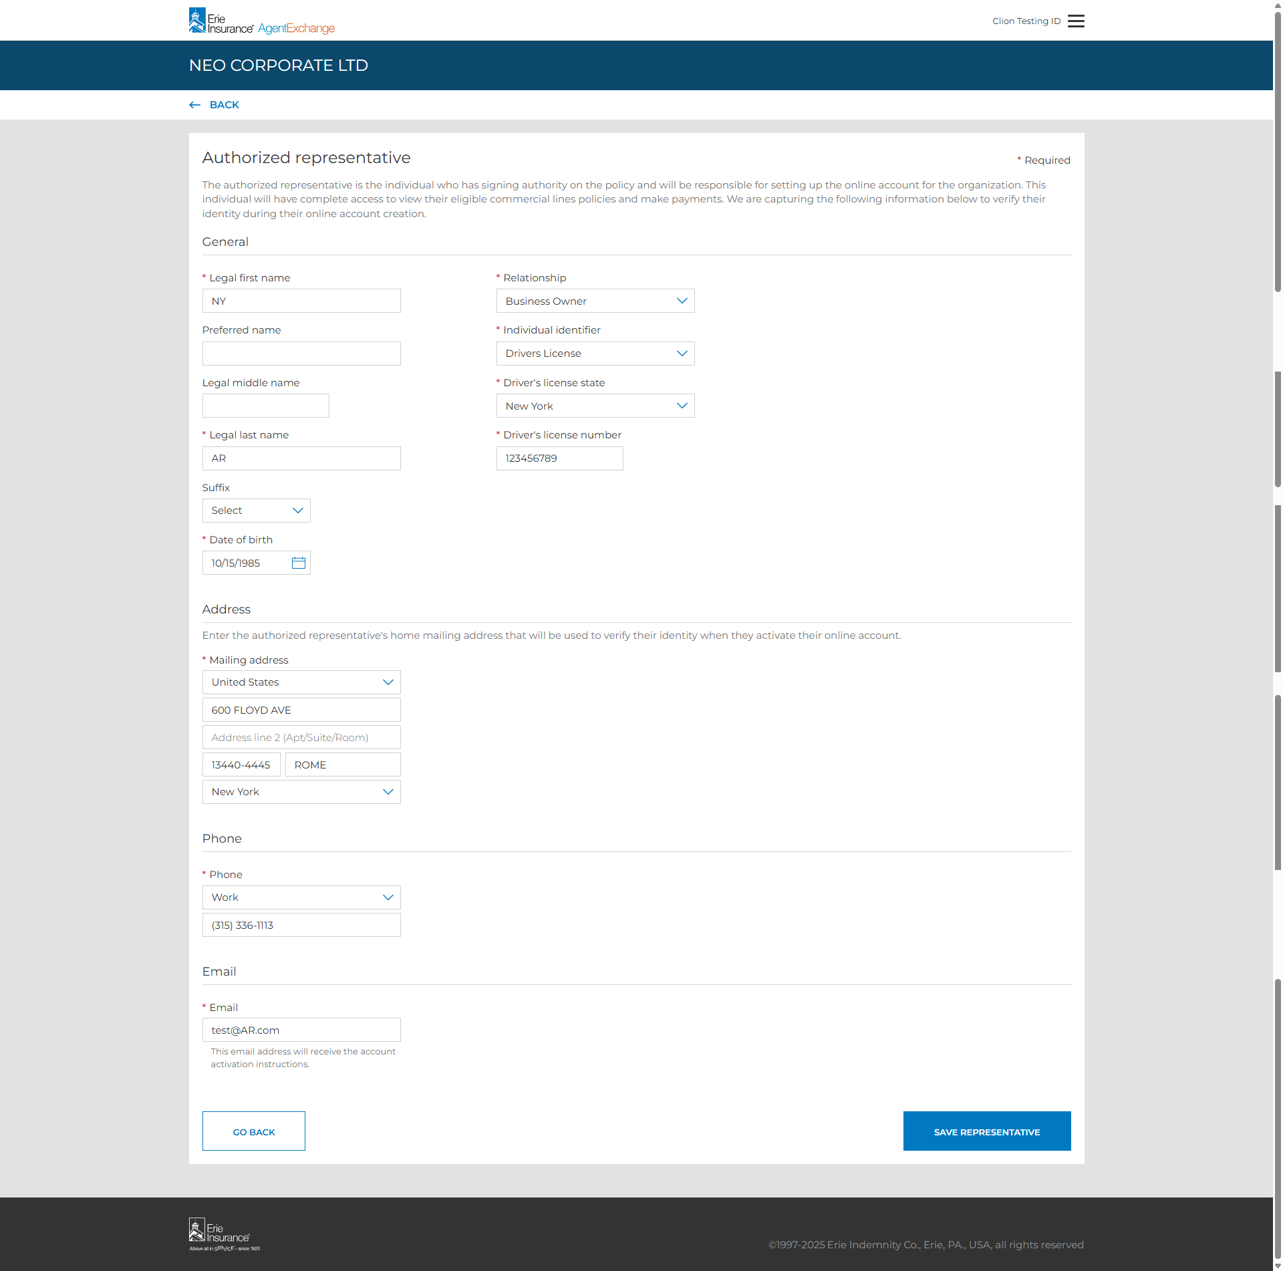

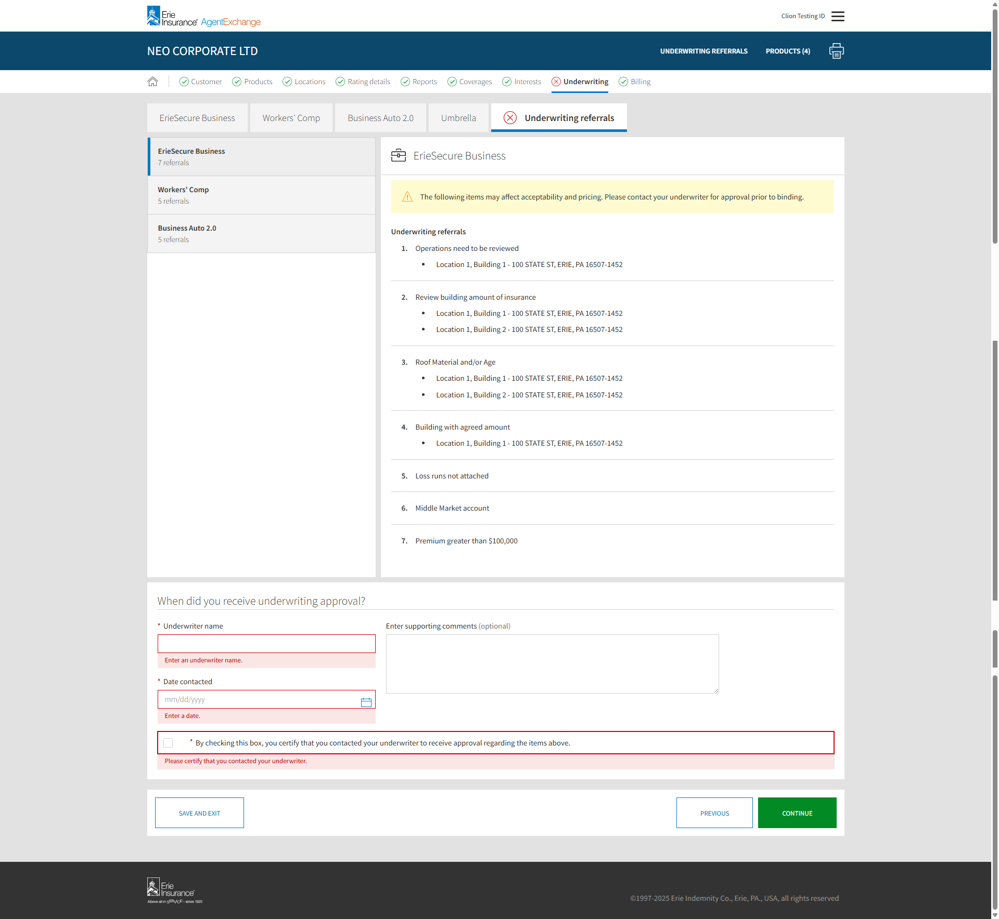

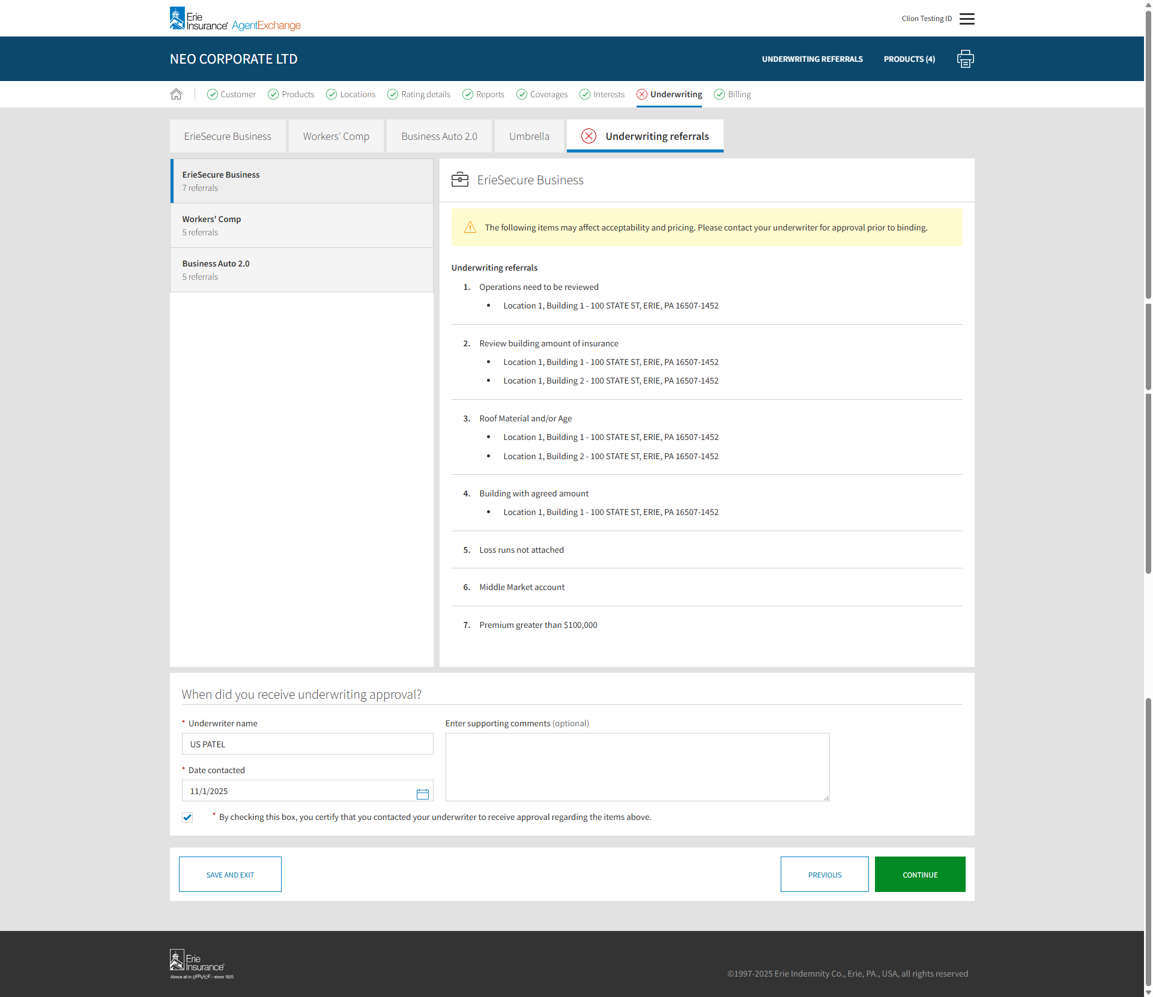

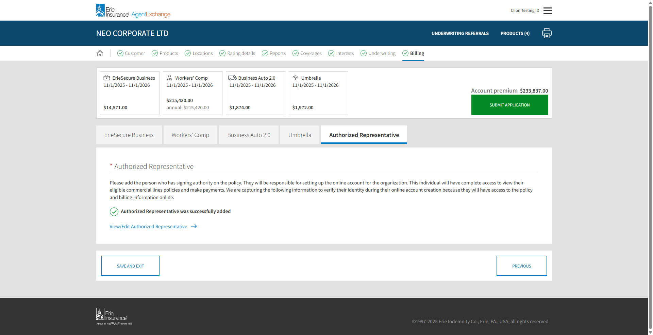

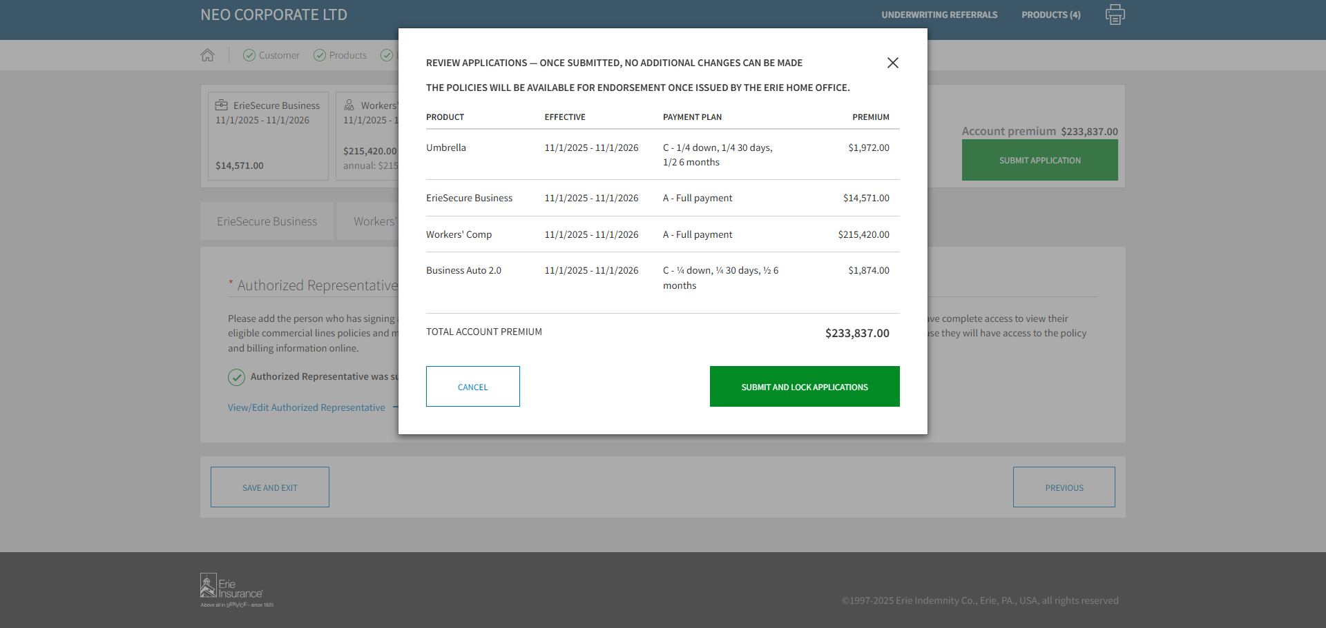

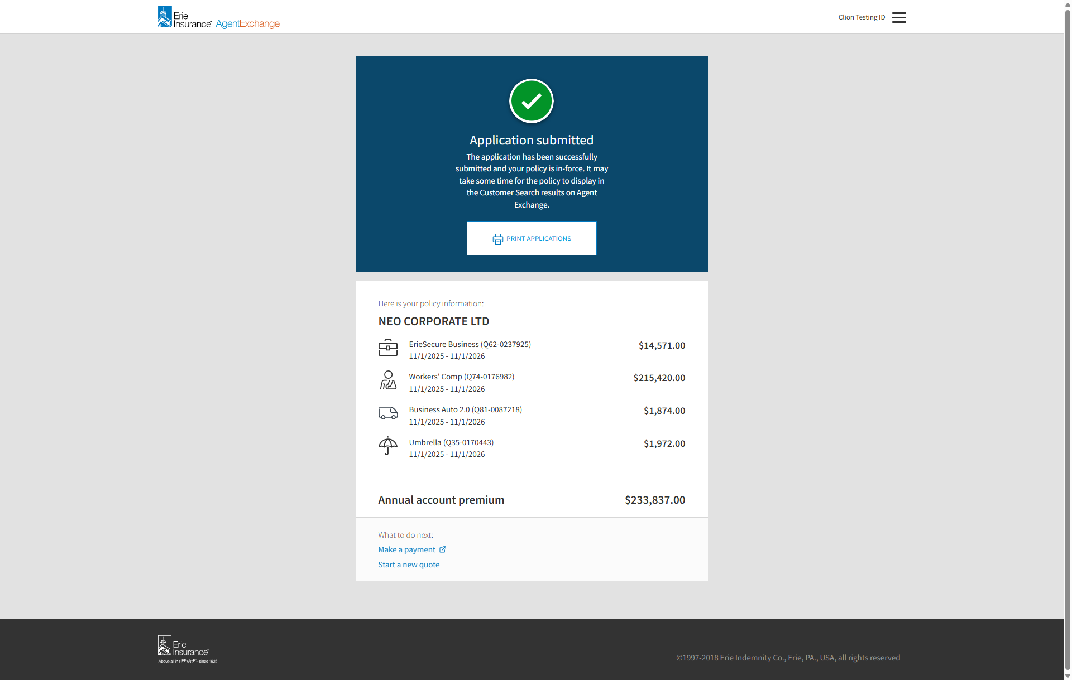





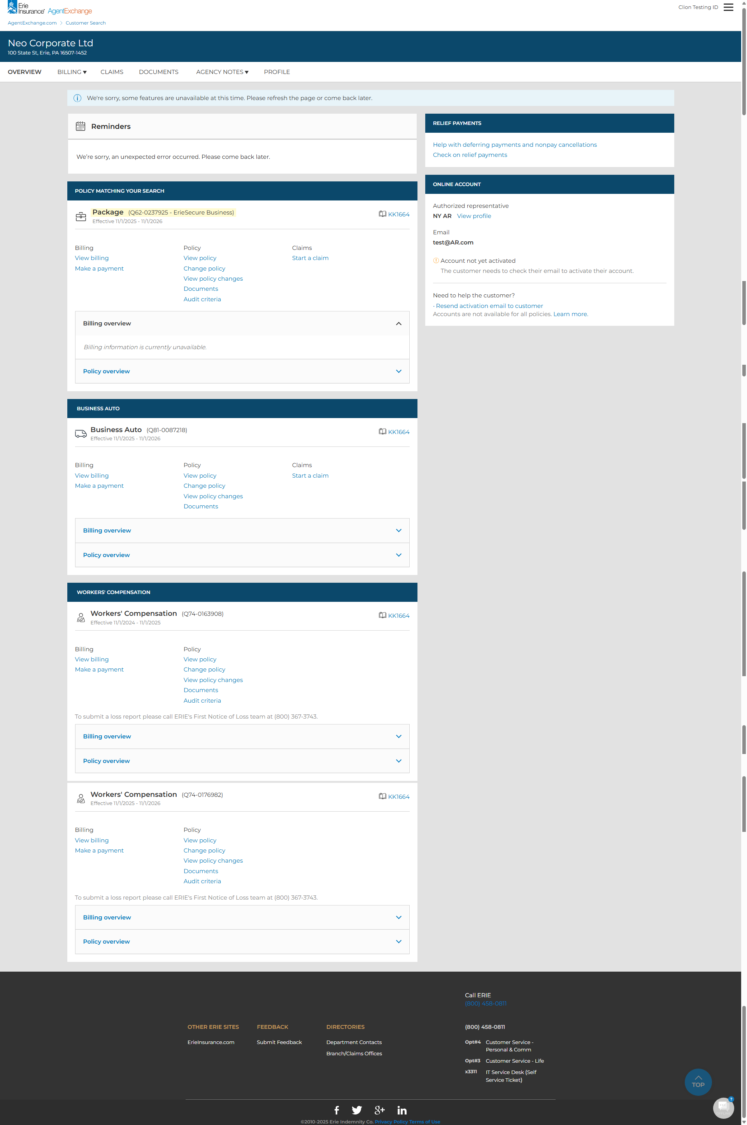

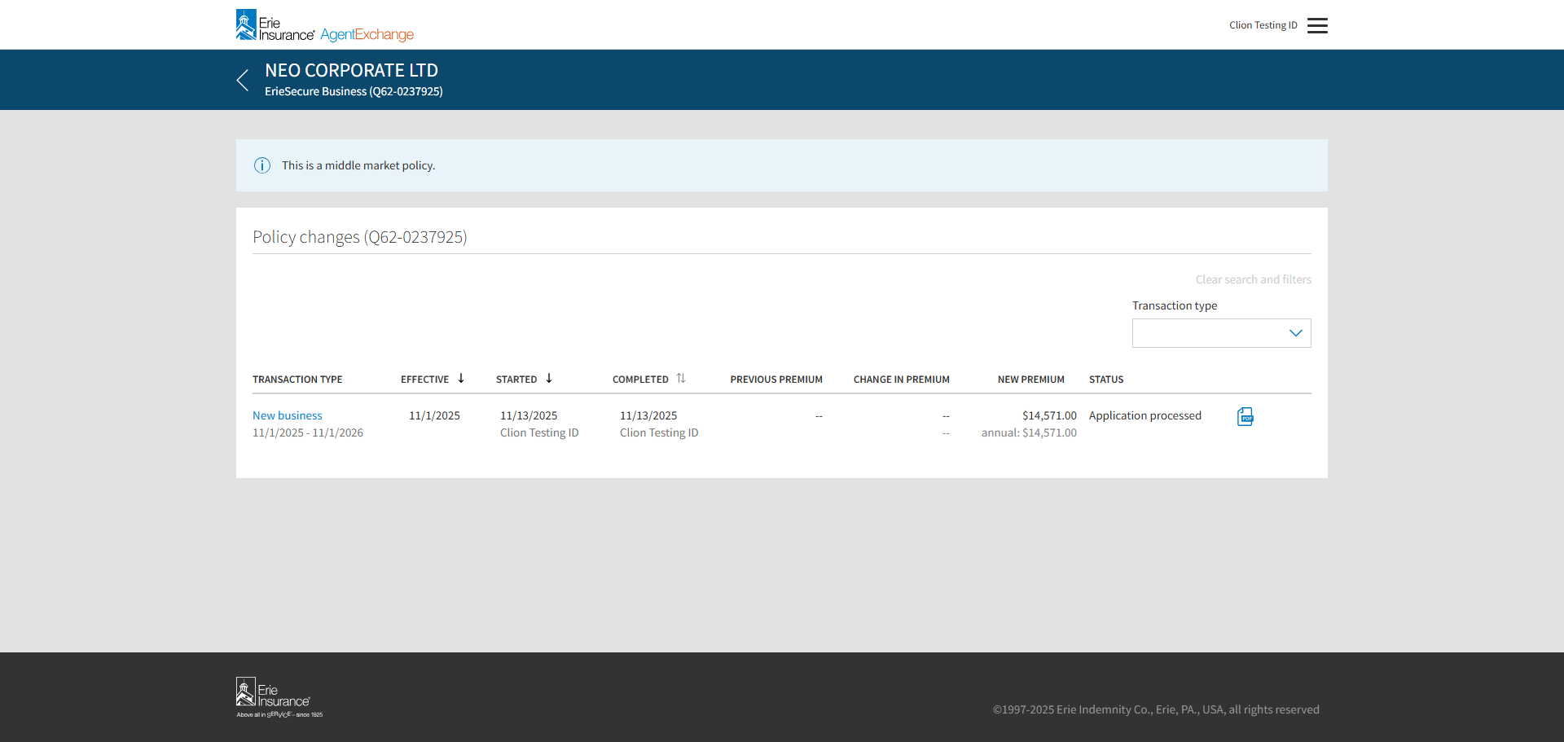

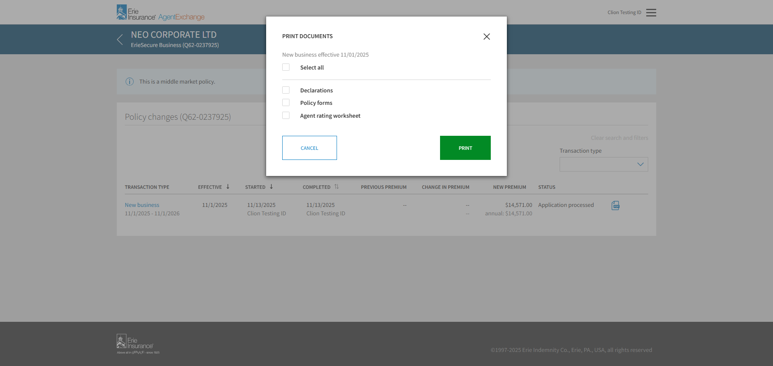

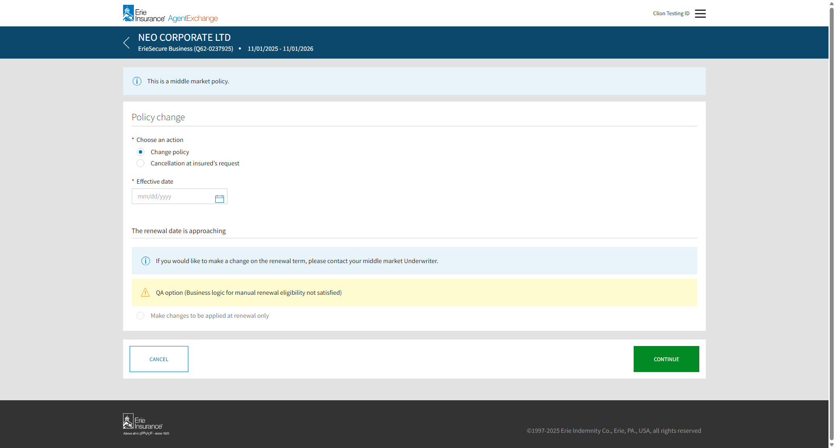

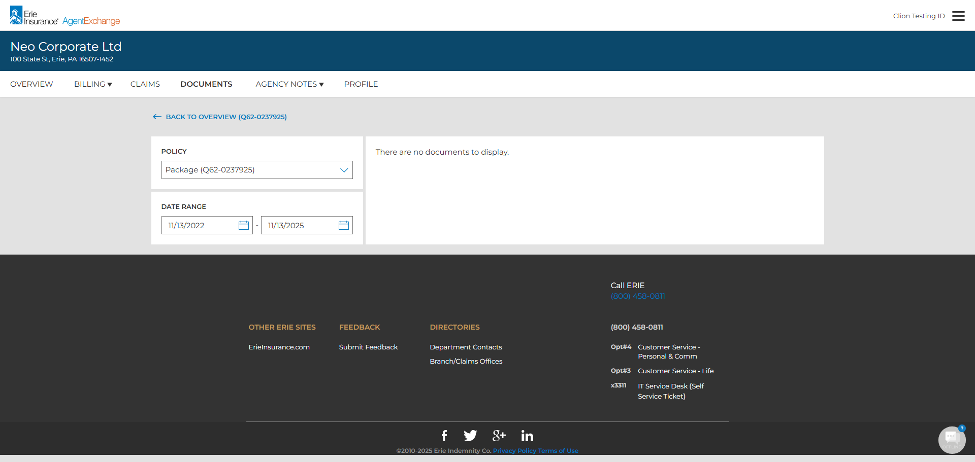

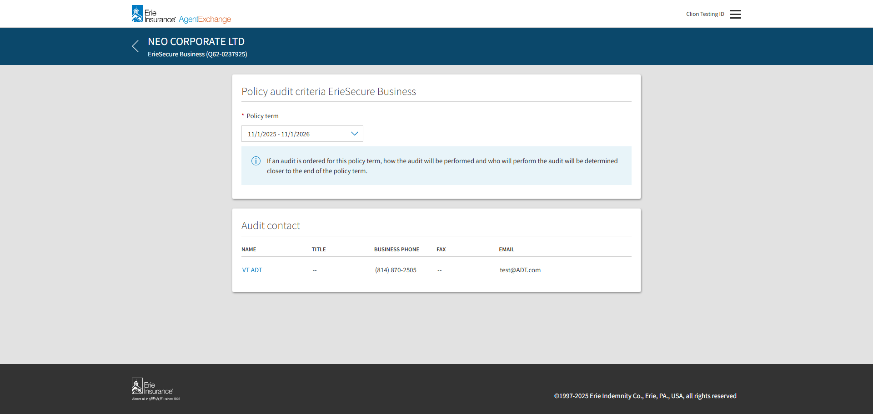

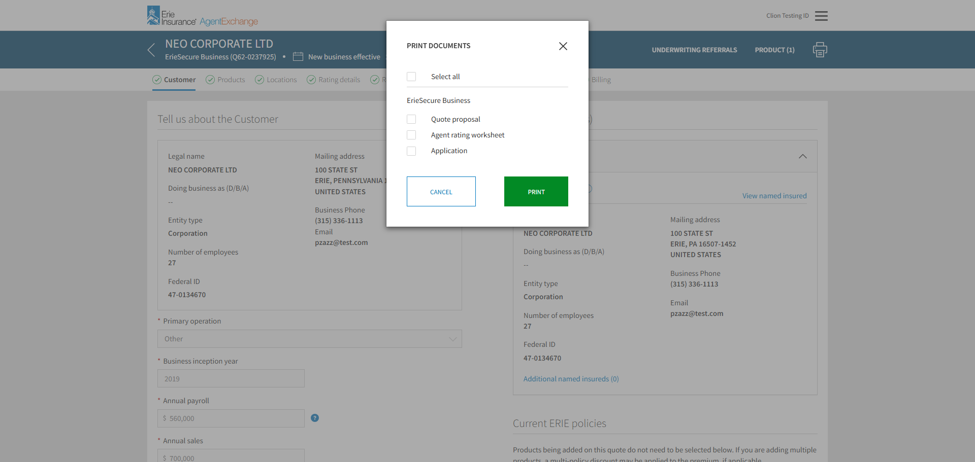

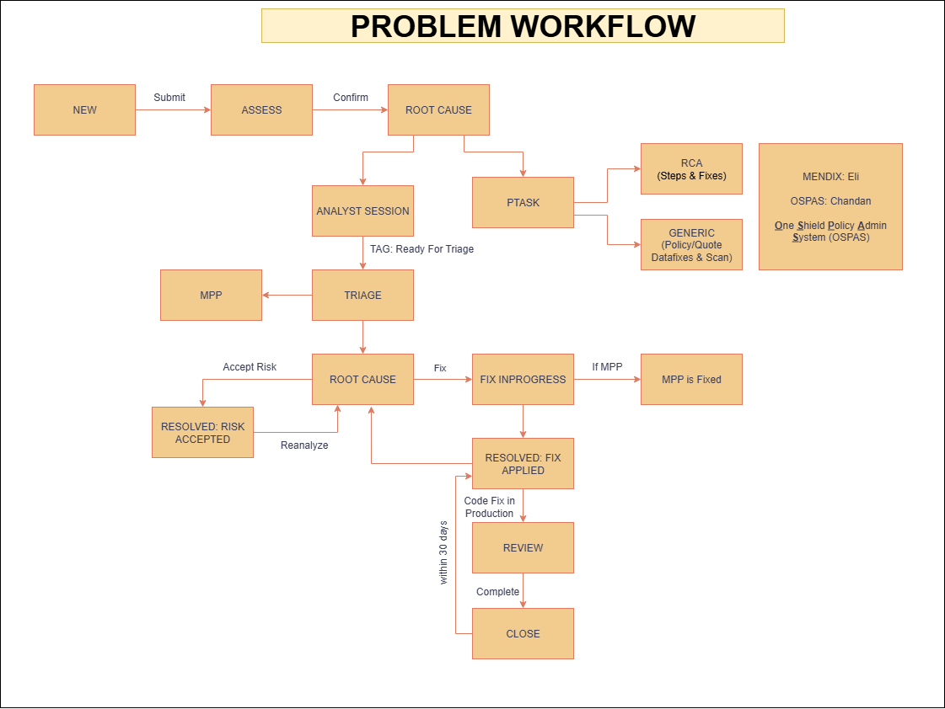

Alisam, Kiran Kumar (VM) <KiranKumar.Alisam@ERieInsurance.com>;

Bach, Eric <Eric.Bach@ErieInsurance.com>;

Bartlett, Jason T. <Jason.Bartlett@ERieInsurance.com>;

Bilka, Nadya L <Nadya.Bilka@ERieInsurance.com>;

Bliss, Diana L. <Diana.Bliss@ERieInsurance.com>;

Bodi, Karunakaran (VM) <Karunakaran.Bodi@ERieInsurance.com>;

Bowers, Sandra <Sandra.Bowers@ERIEinsurance.com>;

Bright, Dawn S. <Dawn.Bright@ERieInsurance.com>;

Campbell, Ian (VM) <Ian.Campbell@ERieInsurance.com>;

Chambers, Misty M. <Misty.Chambers@ERieInsurance.com>;

Chaudhari, Anirban (VM) <Anirban.Chaudhary@ERieInsurance.com>;

Cherukuri, Naveen Chowdary <Naveenchowdary.Cherukuri@ERieInsurance.com>;

Cummings, Joshua E. <Joshua.Cummings@ERieInsurance.com>;

Davala, Vinod Kumar (VM) <VinodKumar.Davala@ERieInsurance.com>;

Easton, Sheena <Sheena.Easton@ERieInsurance.com>;

Fassett, Sheridan T. <Sheridan.Fassett@ERieInsurance.com>;

Ferry, Michael <Michael.Ferry@ERieInsurance.com>;

Fleming, Rebecca <Rebecca.Fleming@ErieInsurance.com>;

Frawley, Patrick J. <Patrick.Frawley@ERieInsurance.com>;

Gandham, Sai Satish (VM) <SaiSatish.Gandham@ERieInsurance.com>;

Gollu, Bhargavi (VM) <Bhargavi.Gollu@ERieInsurance.com>;

Gowdru, Prashanth (VM) <Prashanth.Gowdru@ERieInsurance.com>;

Gudise, Sham (VM) <Sham.Gudise@ERieInsurance.com>;

Gummula, Srinivas (VM) <Srinivas.Gummula@ERieInsurance.com>;

Herrmann, Clemens J. <Clemens.Herrmann@ERieInsurance.com>;

Hinman, Michelle T. <Michelle.Hinman@ERIEinsurance.com>;

Janke, Danielle <Danielle.Janke@ERIEinsurance.com>;

Joseph Pattathil, Subin (VM) <Subin.JosephPattathil@ERieInsurance.com>;

Kalinowski, Geoffrey <Geoffrey.Kalinowski@ErieInsurance.com>;

Kanhere, Jyoti Vivek (VM) <JyotiVivek.Kanhere@ERieInsurance.com>;

Karns, Abby <Abby.Karns@ERieInsurance.com>;

Kasetty, Meghana (VM) <Meghana.Kasetty@ERieInsurance.com>;

Kirkwood, Simon <Simon.Kirkwood@ERieInsurance.com>;

Ksheersagar, Kiran Kumar (VM) <KiranKumar.Ksheersagar@ERieInsurance.com>;

Kyatanavar, Rashmi (VM) <Rashmi.Kyatanavar@ERieInsurance.com>;

Madane, Sagar S. <Sagar.Madane@ERieInsurance.com>;

Madisetti, Rakesh (VM) <Rakesh.Madisetti@ERieInsurance.com>;

Mccrea, Kegan <Kegan.Mccrea@ERieInsurance.com>;

Mehmedovic, Anel <Anel.Mehmedovic@ERieInsurance.com>;

Miller, Patty <Patricia.Miller@erieinsurance.com>;

Mulasthanam, Muralidhara (VM) <Muralidhara.Mulasthanam@ERieInsurance.com>;

Muthusamy, Mayakannan (VM) <Mayakannan.Muthusamy@ERieInsurance.com>;

Nammi, Naveen Kumar (VM) <NaveenKumar.Nammi@ERieInsurance.com>;

Narindi, Srinu Vara Prasad Rao (VM) <SrinuVaraPrasadRao.Narindi@ERieInsurance.com>;

Nethi, Satya Manikanta (VM) <SatyaManikanta.Nethi@ERieInsurance.com>;

Nguyen, Emma <Trang.Nguyen@ERieInsurance.com>;

O'Donnell, Nicole A. <Nicole.O'Donnell@erieinsurance.com>;

Oldach, Matthew G <Matthew.Oldach@ERieInsurance.com>;

Palmer, Wes <Wesley.Palmer@ERieInsurance.com>;

Paulson, Kimberly <Kimberly.Paulson@ErieInsurance.com>;

Peyyala, Jyothi (VM) <Jyothi.Peyyala@ERieInsurance.com>;

Pilliteri, Adella M. <Adella.Pilliteri@ERieInsurance.com>;

Rangu, Suresh (VM) <Suresh.Rangu@ERieInsurance.com>;

Reid, Derrick <Derrick.Reid@ERieInsurance.com>;

Russo, Kellie <Kellie.Russo@ErieInsurance.com>;

Rydzewski, Elijah L. <Elijah.Rydzewski@ERieInsurance.com>;

Schall, Julia F. <Julia.Schall@ERieInsurance.com>;

Seetharaman, Varadharajan (VM) <Varadharajan.Seetharaman@ERieInsurance.com>;

Sims, Xavier (VM) <Xavier.Sims@ERieInsurance.com>;

Stallworth, MaryAnne (VM) <MaryAnne.Stallworth@ERieInsurance.com>;

Stankiewicz, Vincent <Vincent.Stankiewicz@ERieInsurance.com>;

Suddala, Chandan Kumar (VM) <ChandanKumar.Suddala@ERieInsurance.com>;

Titus, Nicholas A. <Nicholas.Titus@ERieInsurance.com>;

Vuyyuru, Navya <Navya.Vuyyuru@ERieInsurance.com>;

Will, Trisha <Trisha.Will@erieinsurance.com>;

Yarramothu, Koteswara Rao (VM) <KoteswaraRao.Yarramothu@ERieInsurance.com>;

Yarramothu, Swathi (VM) <Swathi.Yarramothu@ERieInsurance.com>;

Yeager, Jennifer L. <Jennifer.Yeager@erieinsurance.com>;

Ziner, Danielle <Danielle.Ziner@ERieInsurance.com>